**CSE 644 INTERNET SECURITY**

**Linux Firewall Exploration Lab**

**Arunbalaji Sivakumar(asivak01@syr.edu)**

**Contents:**

Task 1:………………………………………………………….. 2

Task 2:………………………………………………………….. 5

Task 3:………………………………………………………….. 11

3a:………………………………………………………… 11

3b:………………………………………………………… 13

Task 4:………………………………………………………….. 17

4a:………………………………………………………… 17

4b:………………………………………………………… 22

4c:………………………………………………………… 23

**Programs:**

Task 2: LKM_netfilter_rules.c:………………………………… 26

Task 2: LKM_fortune_cookie.c:………………………………. 30

Task 4c 1: myprog.pl:…………………………………………. 40

Task 4c 2: page_redirect.pl:...…………………………………. 40

Task 4c 3: image_redirect.pl:.…………………………………. 40

**Task 1: Using Firewall**

1. Prevent A from doing telnet to Machine B.
2. Prevent B from doing telnet to Machine A.
3. Prevent A from visiting an external web site. You can choose any web site that you like to

block, but keep in mind, some web servers have multiple IP addresses.

**Answer:**

Step 1:

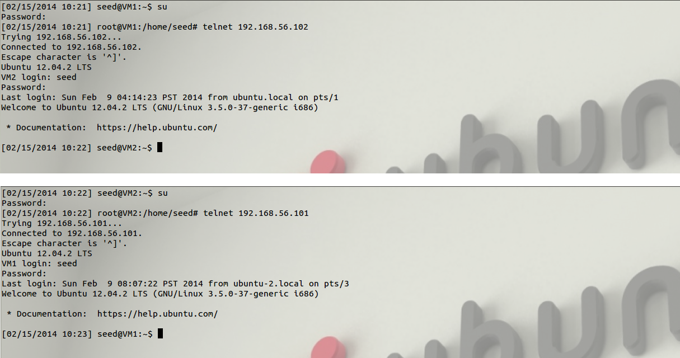

**Observation:**

The machine A(VM1) has the ip address – 192.168.56.101 and machine B(VM2) has the

ip address – 192.168.56.102. When the ufw firewall is not enabled on both the virtual machines, both of them are able to telnet to each other.

Step 2:

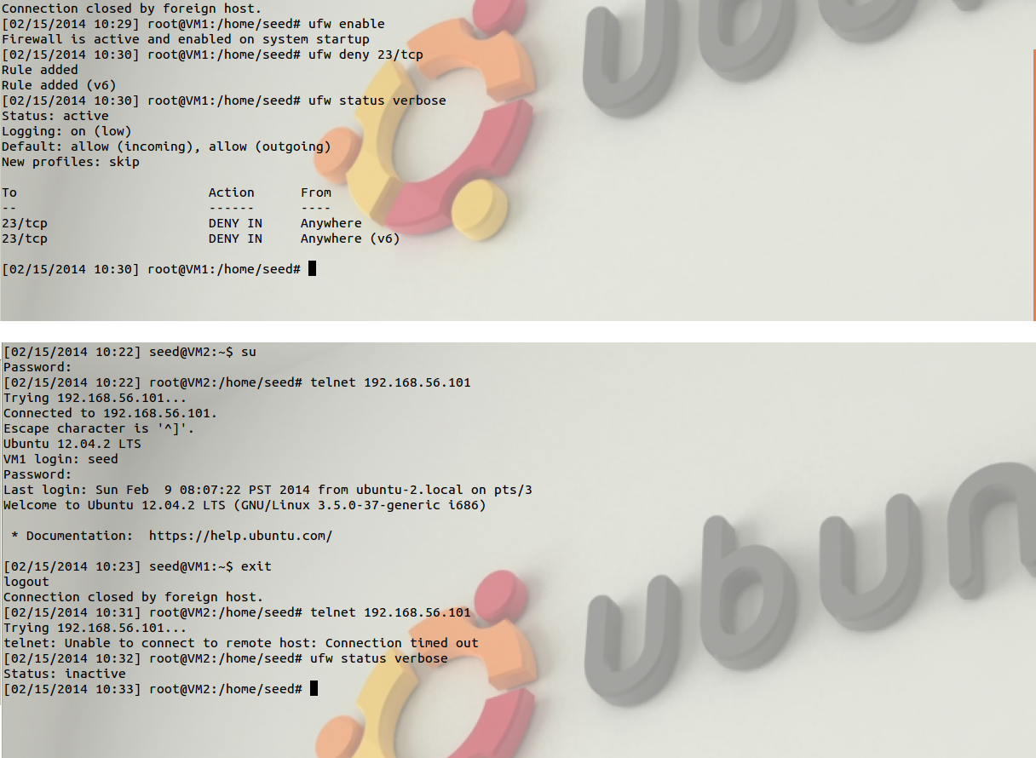

**Observation:**

The ufw firewall can be used only under root privilege as only the administrator can access the controls of firewall. The ufw is enabled only on VM1 using the command “ufw enable” under root privilege. The incoming telnet packets to VM1 are blocked using the ufw policy “ufw deny 23/tcp”. By default all rules are applied to incoming packets. So when VM2 tries to telnet VM1 again using the mac address in the arp table, it is blocked. VM1 can still telnet VM2 since there no rule to block outgoing packets.

Step 3:

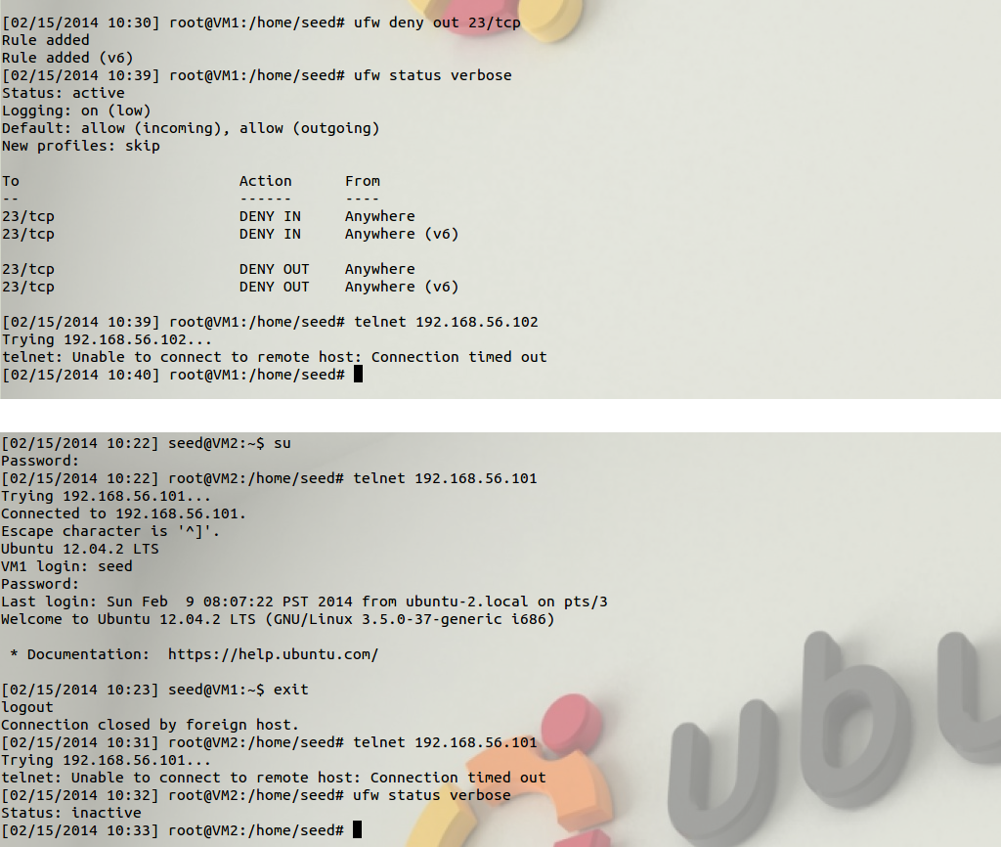

**Observation:**

To prevent VM1 to telnet to VM2 a ufw policy “ufw deny out 23/tcp” is added in VM1. So when VM1 tries to telnet to VM2 using mac address from arp table it is denied. ufw policy can also be added in VM2 but it is easy to maintain the firewall constraints in a single virtual machine unless it is required to add on both the virtual machines.

Step 3:

ufw policy can be added to block or allow access to external links such as websites.

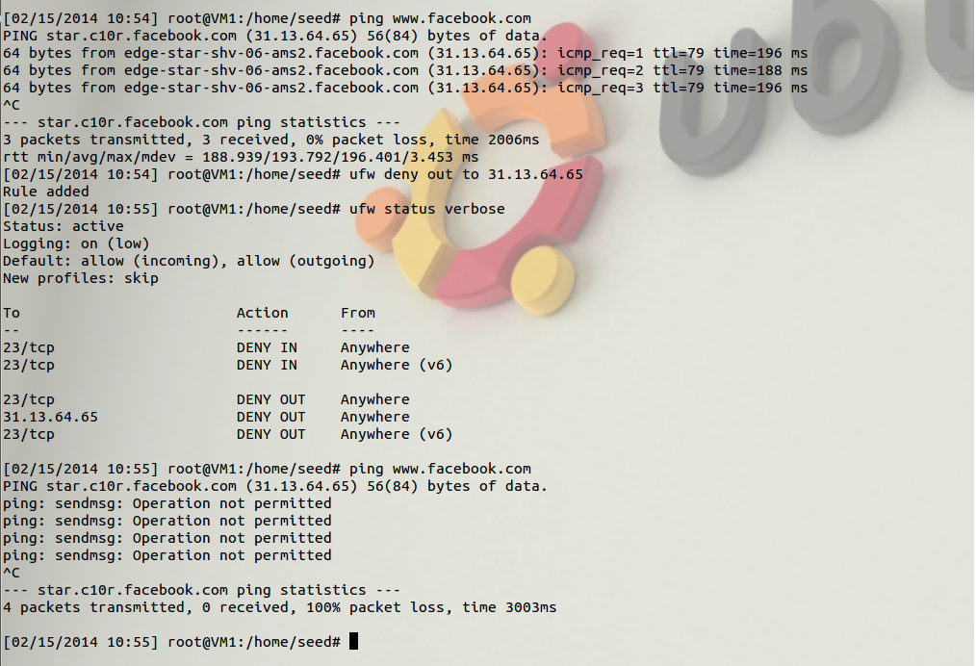

**Observation:**

As there is no firewall policy enforced on the ip address of facebook, VM1 can ping facebook. Facebook can be blocked using ufw and its ip address. The ufw policy “deny out to 31.13.64.65” blocks all outgoing packets that have the destination ip address as 31.13.64.65. So when VM1 tries to access facebook again it is denied by the firewall.

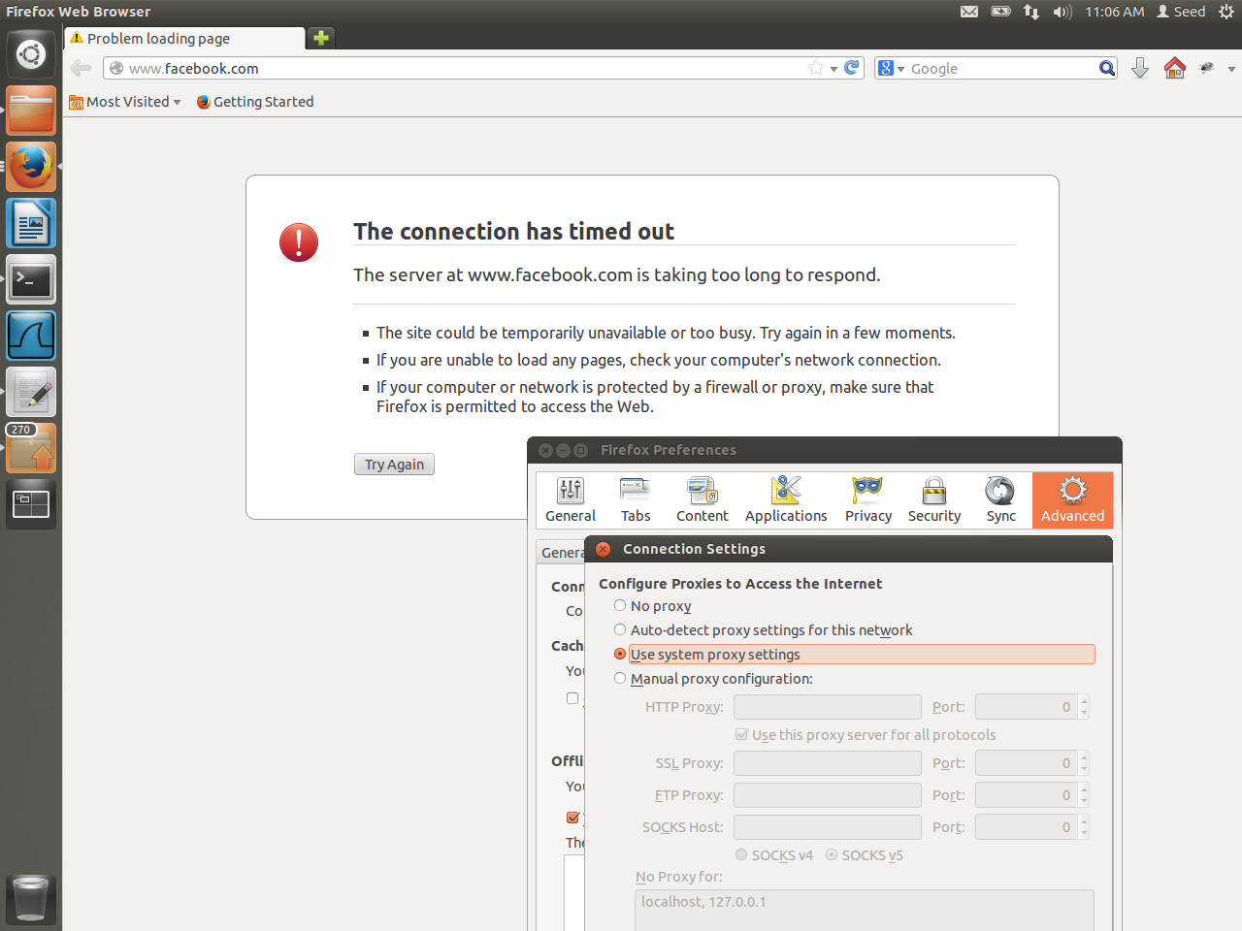

**Task 2:**

**Loadable Kernel Module and Netfilter:**

Firewall policies can also be added in the kernel space using Loadable Kernel Module(LKM) and netfilter. The program is hardcoded and loaded into kernel as modules.

In this task some firewall rules added using neetfilter and LKM into the kernel.

The program is available at page : 26(LKM_netfilter_rules.c)

**Rules:**

VM1 (192.168.56.101), VM2 (192.168.56.102) and VM3 (192.168.56.103).

For incoming packets:

* Drop icmp request packet from VM2.
* Drop all telnet packets.
* Drop all packets from VM3.

For outgoing packets:

* Drop telnet request packets.
* Drop ftp request packets.
* Block access to [www.facebook.com](http://www.facebook.com)
* Block access to [www.syr.edu](http://www.syr.edu)

**Initial condition:**

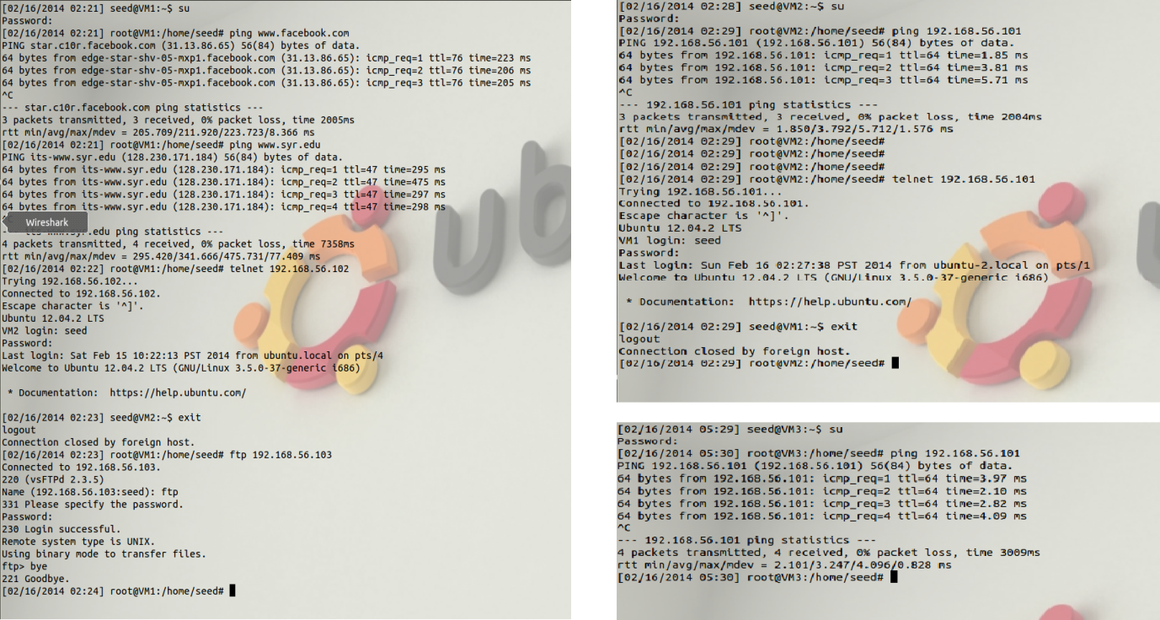

**Observation:**

No firewall policy is enabled on the three virtual machines so they can ping each other, send ftp

or telnet packets and access external websites. The firewall policy is implemented on VM1.

Rule 1:

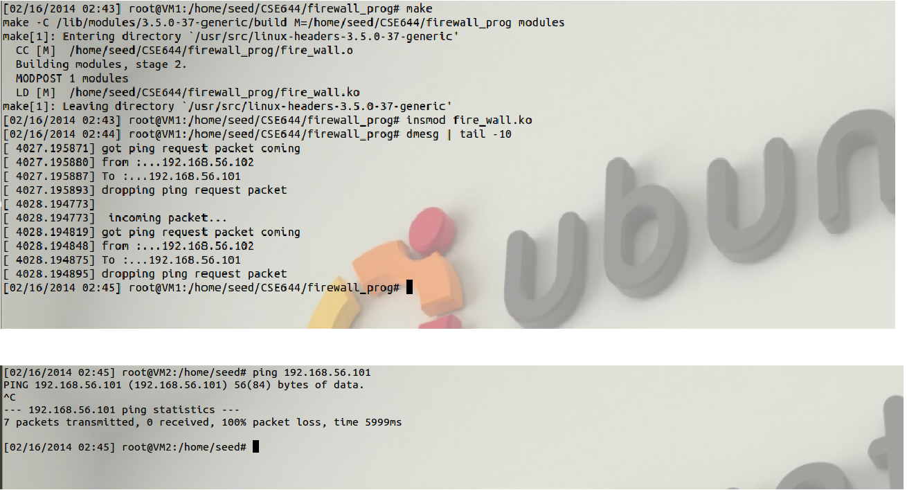

**Observation :**

When VM2 tries to send icmp request to VM1 the firewall policy in VM1 blocks it.

Rule 2:

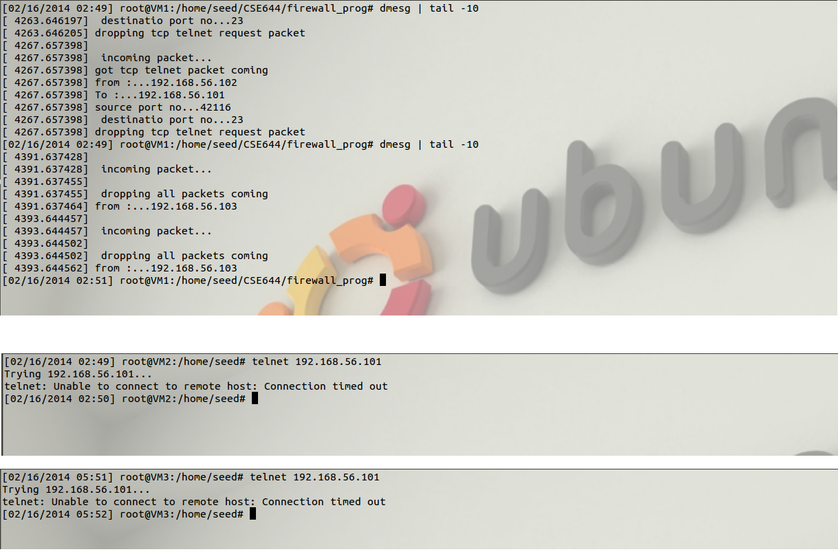

**Observation:**

When VM2 tries to telnet VM1 the firewall rules blocks it. VM3 cannot send telnet packet to VM1 since firewall blocks all packets coming from VM3.

Rule 3:

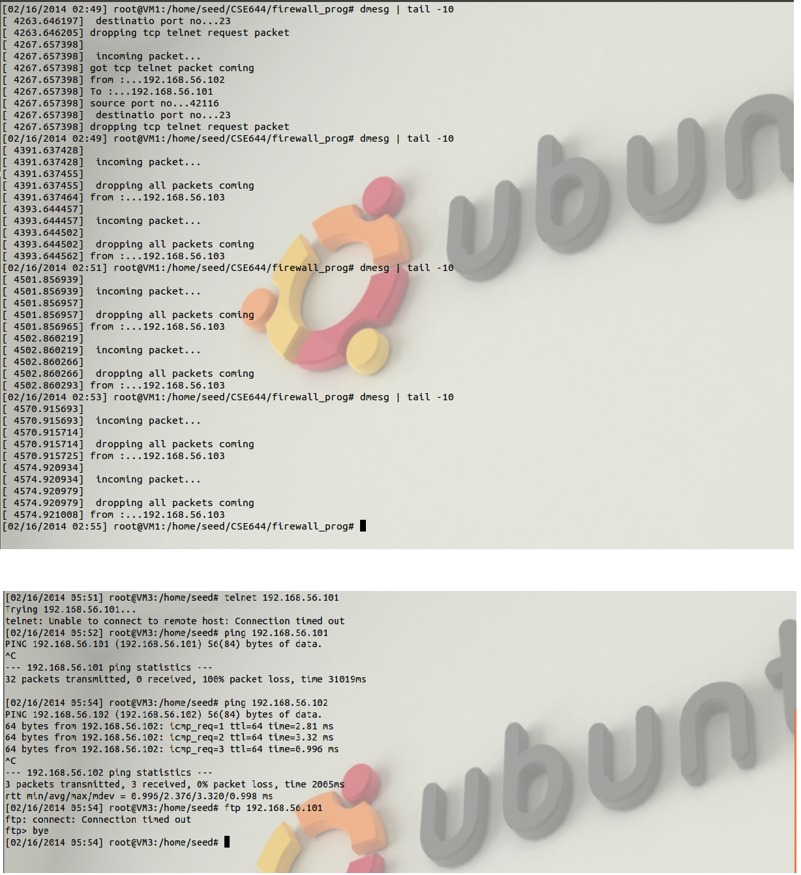

**Observation:**

VM3 cannot send any packets to VM1 since firewall policy blocks all packets from VM3.

Rule 4:

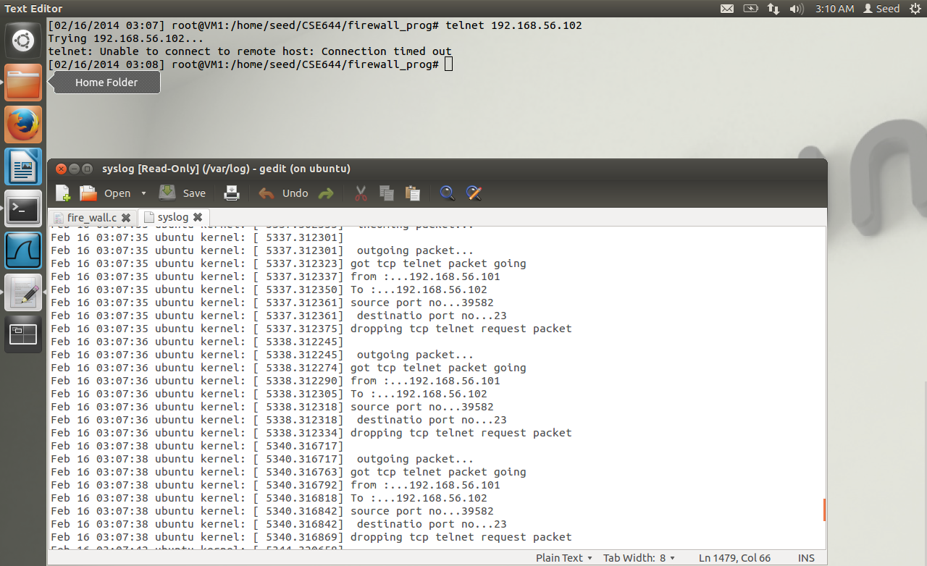

**Observation:**

VM1 cannot telnet to VM2 as firewall policy blocks all telnet request packet from VM1.

Rule 5:

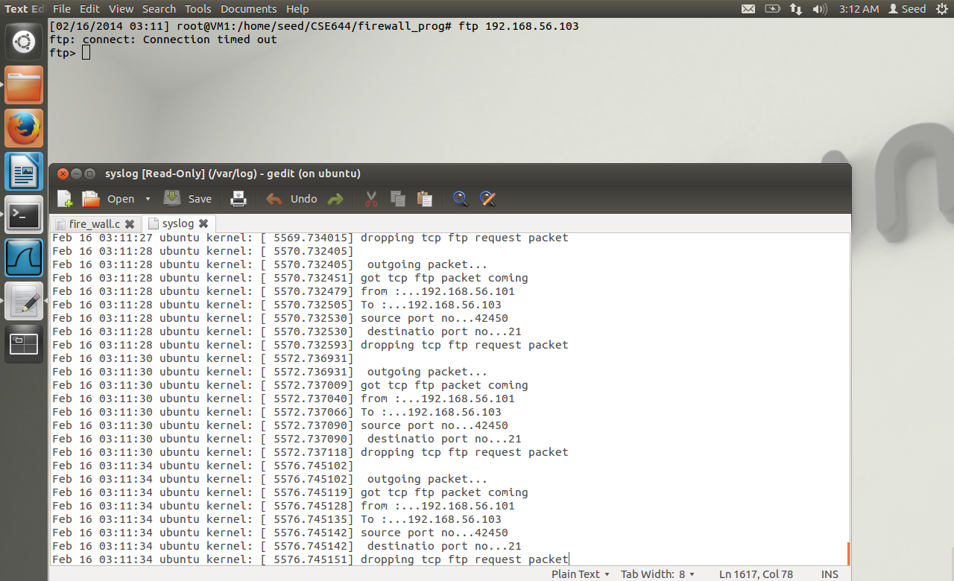

**Observation:**

VM1 cannot send ftp packet to VM2 as firewall policy blocks all ftp request packet from VM1.

Rule 6, 7:

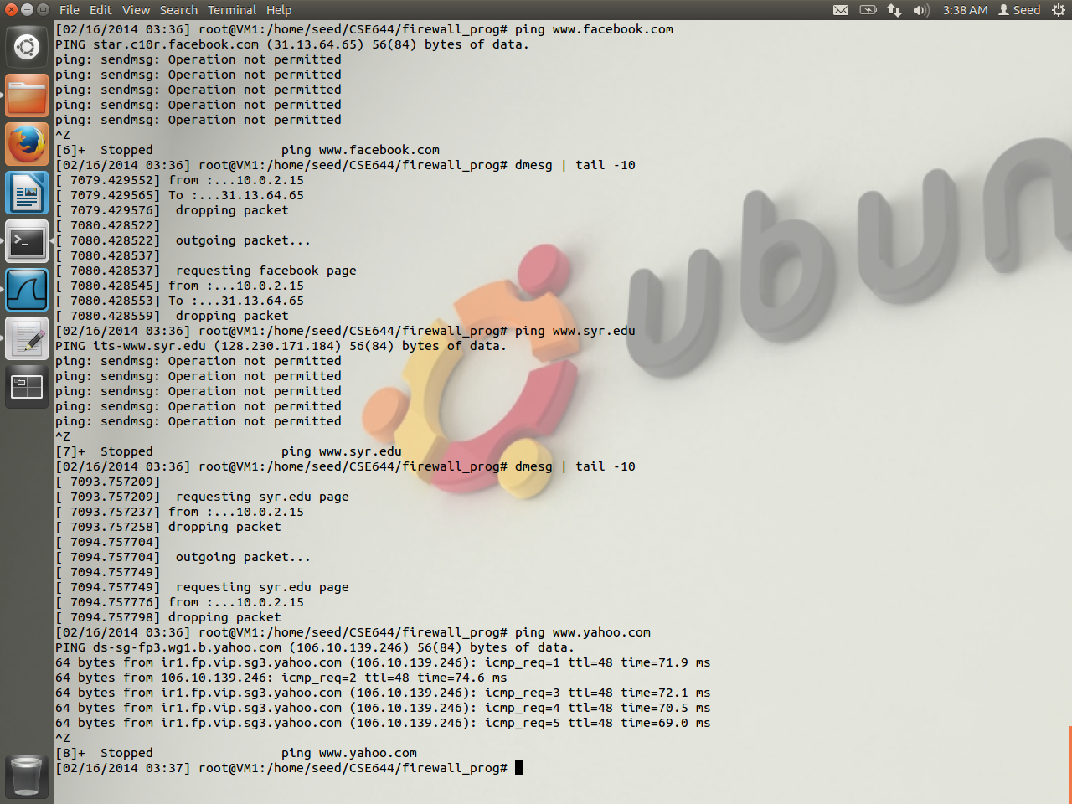

**Observation:**

Firewall prevents VM1 from accessing facebook.com and syr.edu. facebook has multiple ip address so firewall is enabled for all these ip addresses.

**Question 1:**

What types of hooks does netfilter support and what can you do with these hooks?

Please draw a diagram to show how packets flow through these hooks.

Answer:

There are various hooks supported by netfilter. They are defined under protocol specific header file (#include <linux/netfilter_ipv4.h> or #include <linux/netfilter_ipv6.h>). There are five hooks defined for IPv4.

1. NF_INET_PRE_ROUTING

Incoming packets are checked before entering into the routing code. They pass through this hook through ip_rcv() function. Various attacks like denial-of –service can detected in this hook before the packets are processed.

1. NF_INET_LOCAL_IN

After the packets pass through the routing code those packets that are destined to this computer pass this hook function through ip_local_deliver() function.

1. NF_INET_FORWARD

After the packets pass through the routing code those packets that are not destined to this computer pass this hook function through ip_forward() function.

1. NP_INET_LOCAL_OUT

Packets that are created by the local computer pass through this hook. These packets are checked against the rules to filter outgoing packets.

1. NF_INET_POST_ROUTING

Before the packets leave the NIC card of the local computer they are checked in this hook.

G

F

D

B

A

NIC card

NIC card

E

C

A – incoming packets through LAN.

B – NF_INET_PRE_ROUTING, ingress filtering

C – NF_INET_LOCAL_IN

D – NF_INET_FORWARD

E – NF_INET_LOCAL_OUT

F – NF_INET_POST_ROUTING, egress filtering

G – outgoing packets

**Question 2:**

Where should you place a hook for ingress filtering, and where should you place

a hook for egress filtering?

Answer:

Ingress filtering is applied for incoming packets. The hook is placed before the routing code so when the incoming packets pass through the NIC card of the local computer they are processed. It is the first filter applied on packets when they reach in.

Egress filtering is applied for outgoing packets. The hook is placed before the outgoing packets (that is, packets created by the local computer or the packets being forwarded) reach the NIC card. It is the last filter applied on packet before they reach out.

**Question 3:**

Can you modify packets using Netfilter?

Answer:

The purpose of netfilter is to check whether the incoming or outgoing packets they satisfy the firewall policy implemented on the local computer. However they can also be used to modify the packets. Once the Loadable Kernel Module receives a packet through netfilter it can modify it by changing the destination port number or ip address and checksum.

**Optional: answer**

The loadable kernel module(LKM) and fortune cookie program together can provide a dynamic way to implement firewall in kernel module. The fortune cookie write module reads the firewall rules from the user space during run time and loads it into kernel space. Whenever a packet enters the machine it is checked against the rule and then they are processed.

However this program can get only one rule from the user during run time.

The program is available in page number: 30(LKM_fortune_cookie.c)

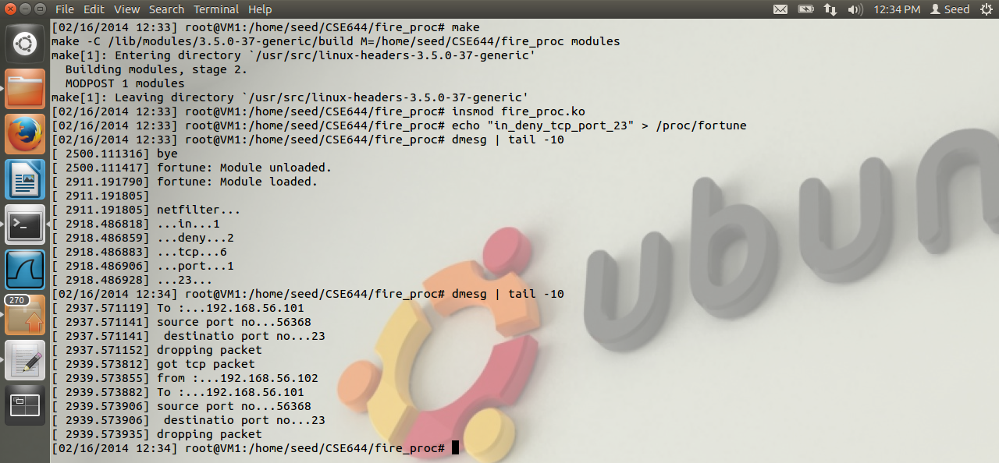

**Task 3: Evading Egress Filtering**

Firewall policies can be bypassed without modifying the existing firewall policies. One such way is to bypass the firewall using Secure Shell(SSH) protocol. Using ssh machine A can create a SSH tunnel through its firewall and connect to another machine B outside its firewall and it can access other machines r websites using machine B. once the connection is established machine A can perform all action, that was block by its firewall, through machine B.

VM1 (192.168.56.101), VM2 (192.168.56.102) and VM3 (192.168.56.103).

**Task 3a: telnet to VM2 through the firewall**

Step 1:

The telnet connection to external machines is blocked in VM1 using ufw firewall policy.

* ufw deny out 23/tcp

step 2:

SSH tunnel is created from VM1 to VM2 in VM1 using the command

* ssh –L 8000:192.168.56.103:23 192.168.56.102

step 3:

After entering into VM2, VM1 can telnet to VM3 using the telnet command.

* telnet 192.168.56.103

So every packet coming from VM3 comes to VM2 and passes through the SSH tunnel and reaches VM1.

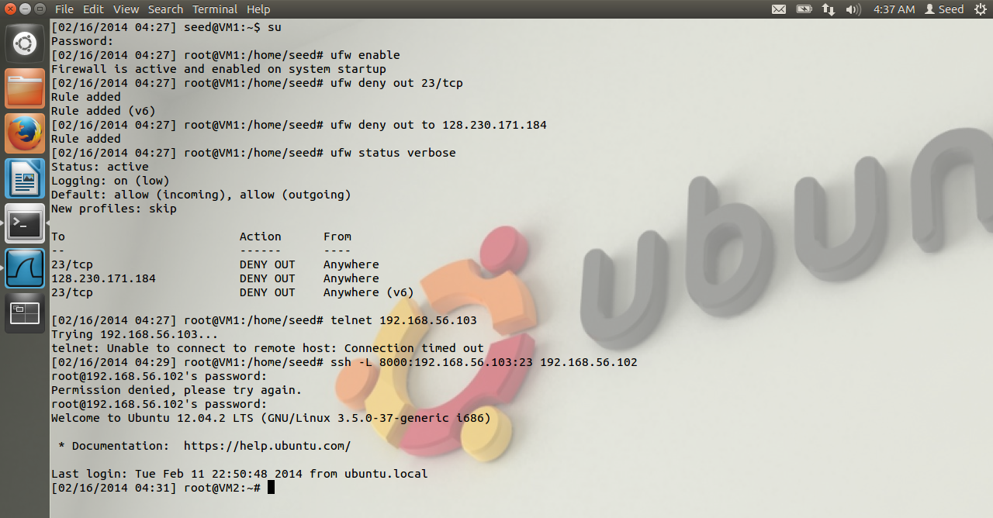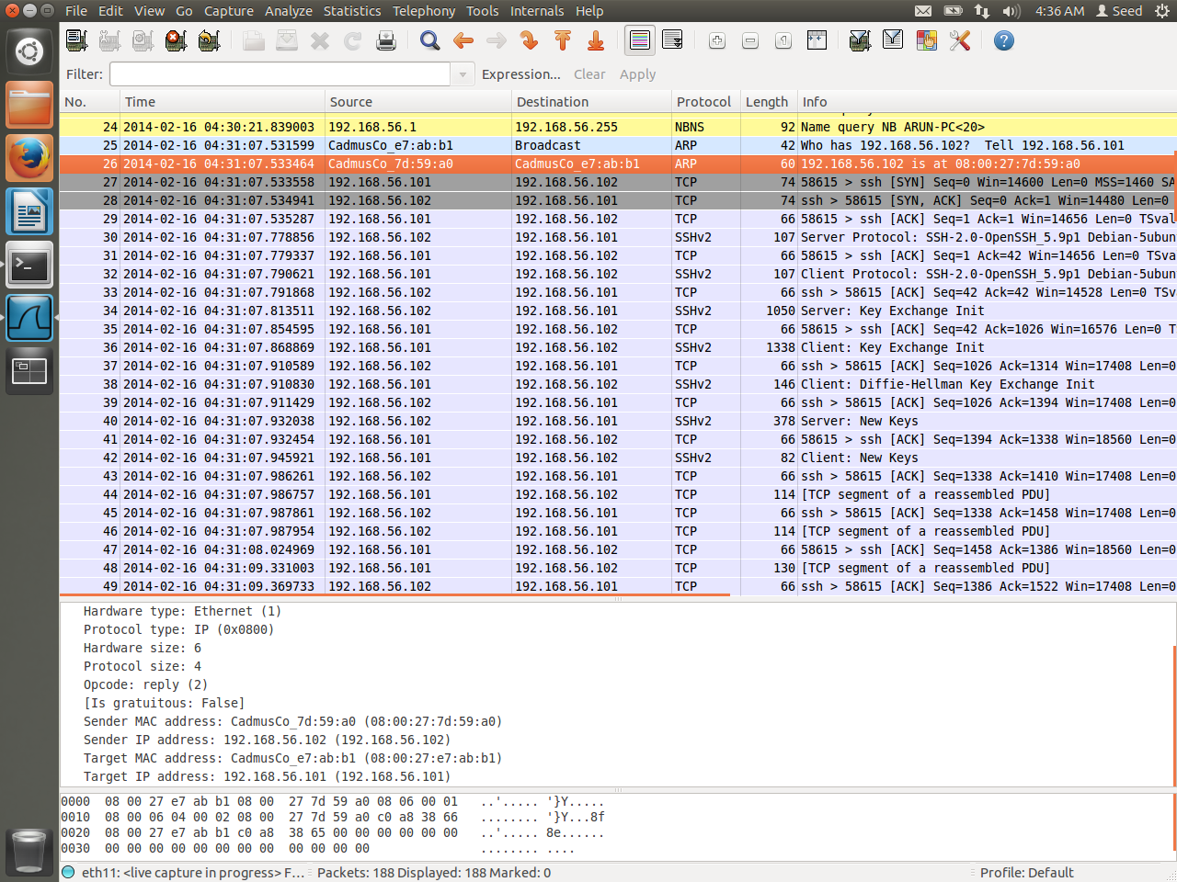

**Observation:**

When VM1 tries to telnet to VM3 it is blocked. So after creating the ssh tunnel VM1 can access VM2.

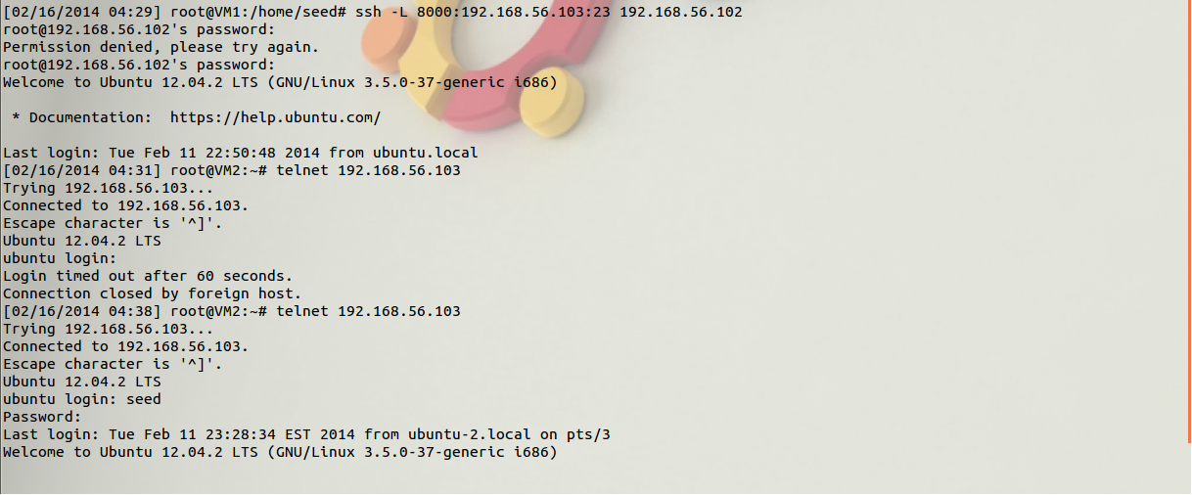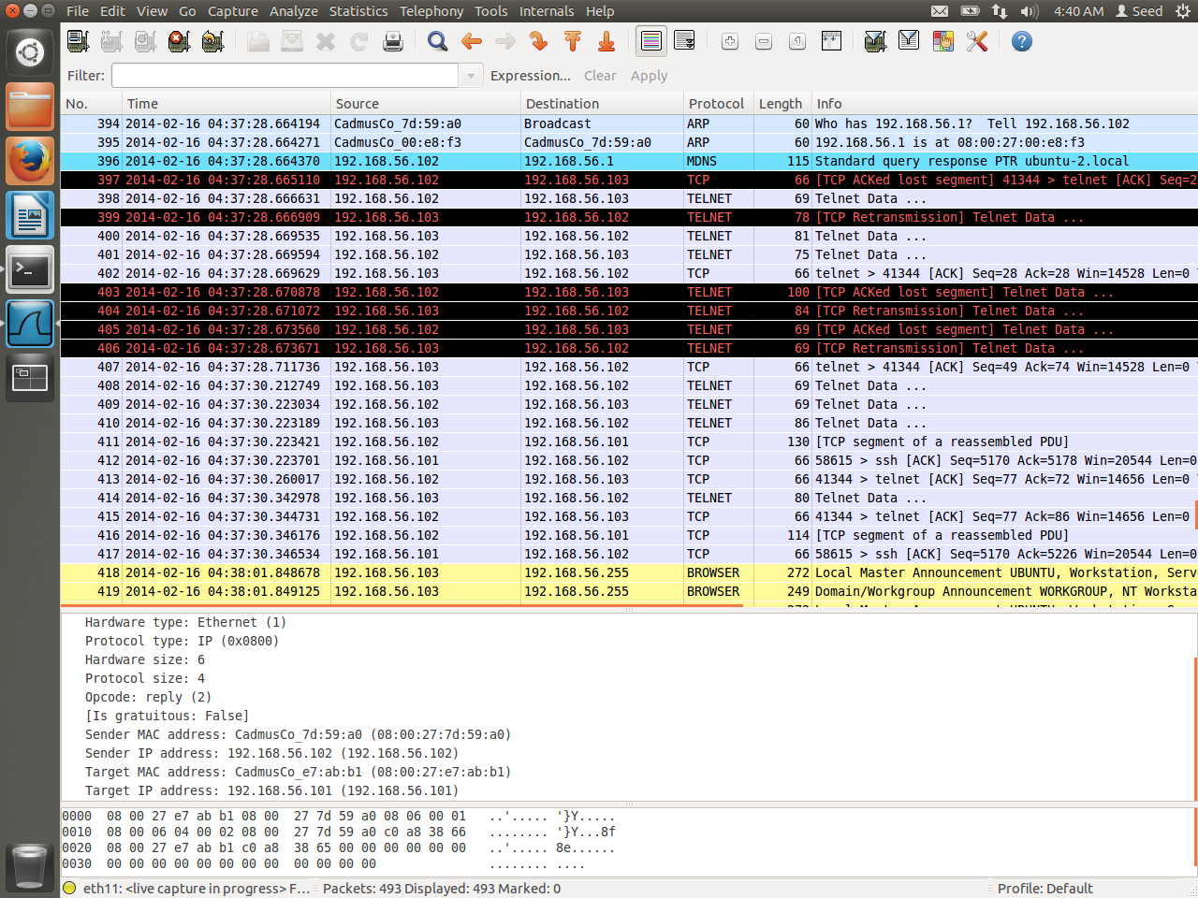

**Observation:**

After VM1 gains access to VM2 it telnet to VM3 and gains access to VM3. Information regarding login and password of VM3 is passed to VM1 through VM2 and SSH tunnel.

**Task 3b: connecting to syr.edu using SSH tunnel**

Step 1.1:

Access to [www.syr.edu](http://www.syr.edu) is blocked in VM1 using “ufw deny out to 128.230.171.184”. VM1 tries

to access [www.syr.edu](http://www.syr.edu) through firefox browser but there is no response. 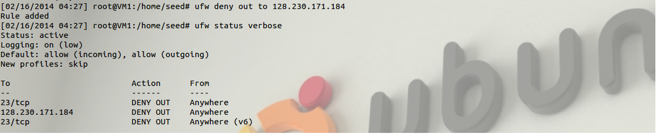

Step 1.2:

VM1 creates a SSH tunnel to VM2 through port 9000.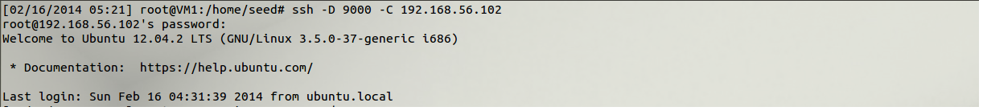

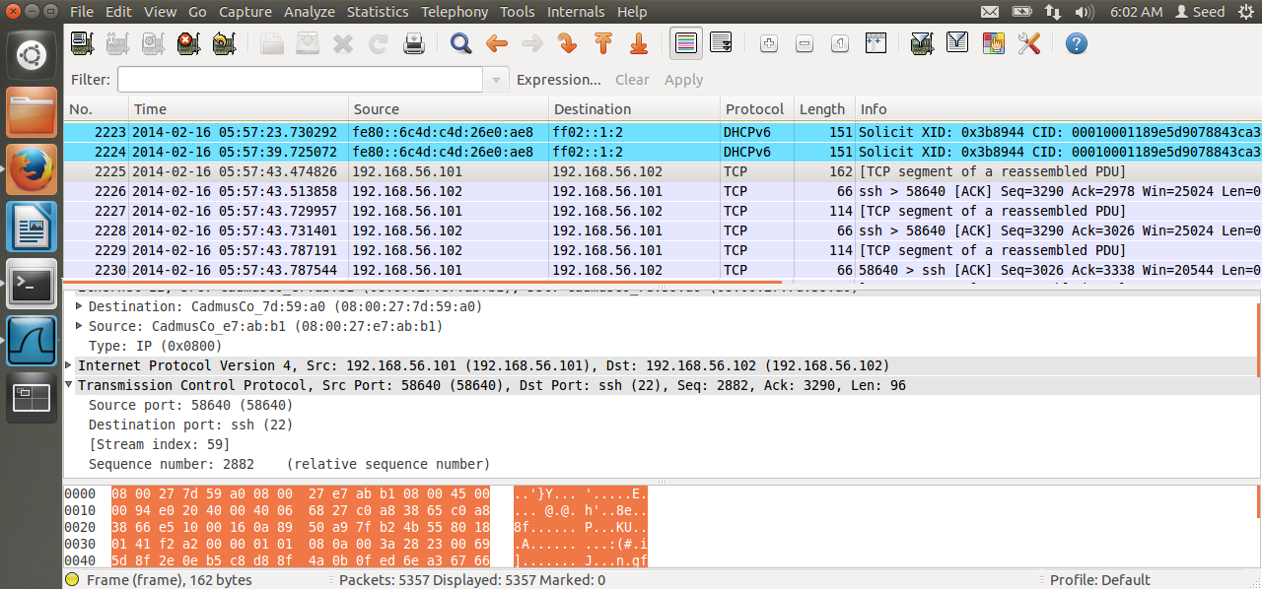

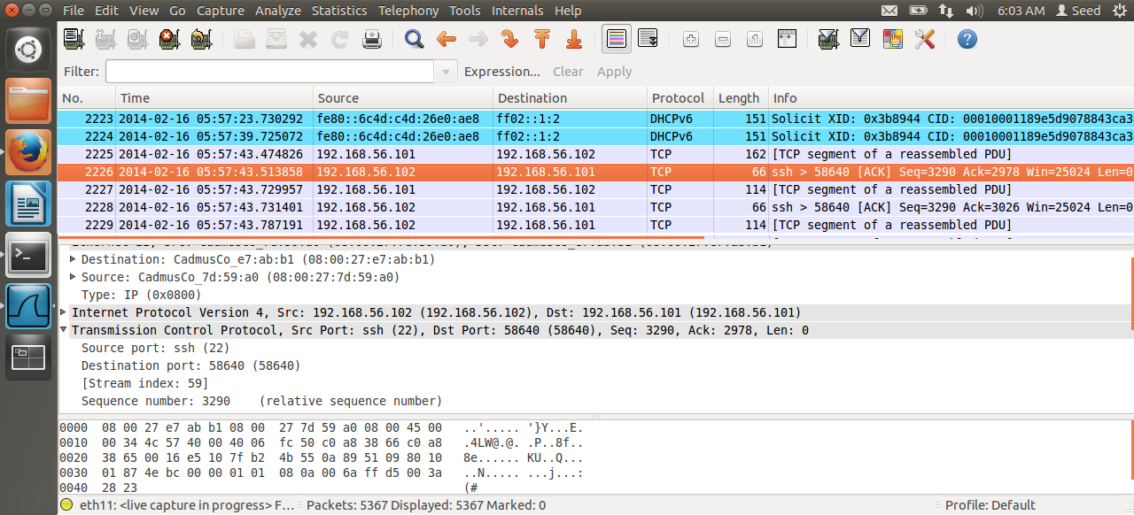

**Observation:**

VM1 and VM2 performs 3-way handshake and establishes connection using the SSH port 22. After establishing connection communicate through TCP protocol.

Step 2:

VM1 breaks the SSH connection from VM2 by exiting VM2.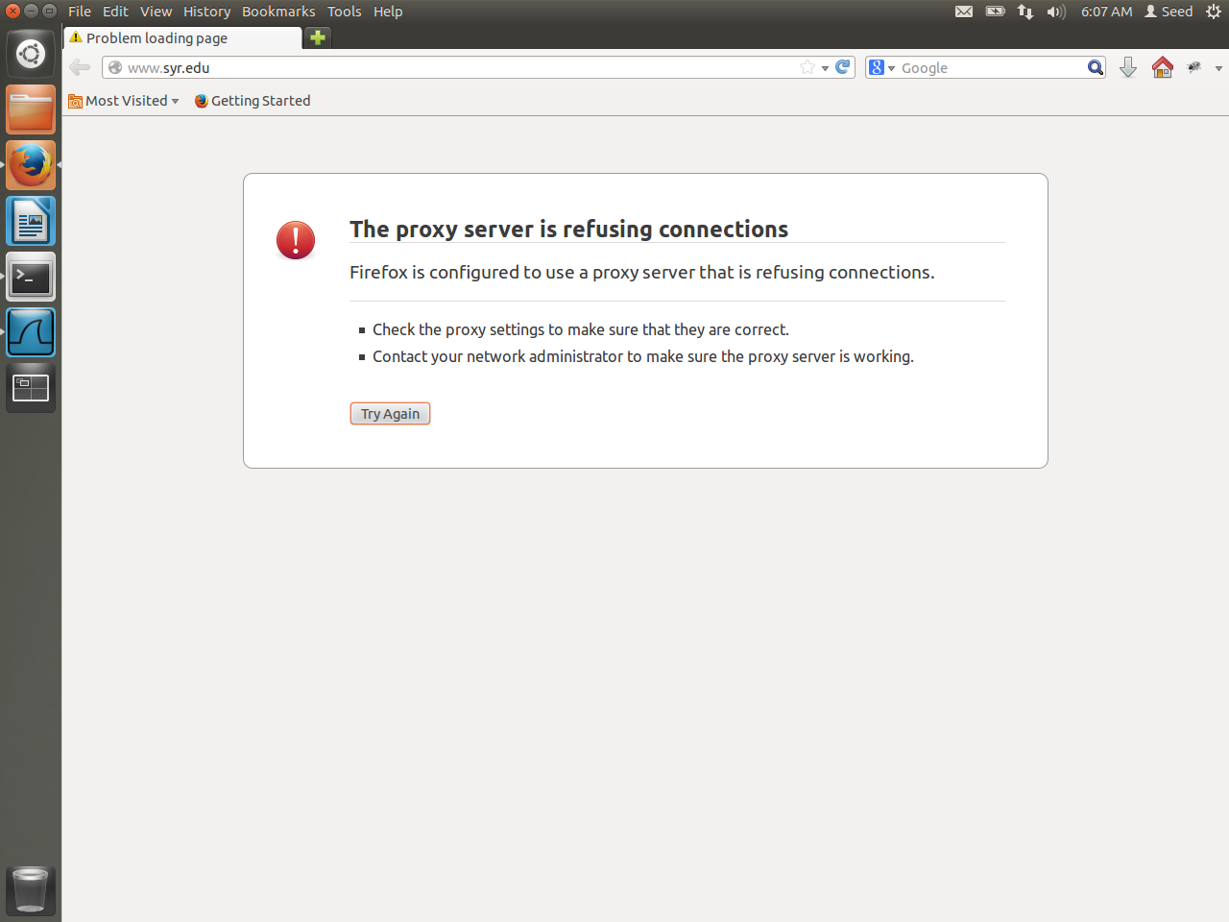

**Observation:**

After breaking SSH connection when VM1 tries to access syr.edu the proxy and port 9000 refuses the connection since it cannot connect to VM2.

Step 3:

VM1 again establishes SSH connection to VM2.

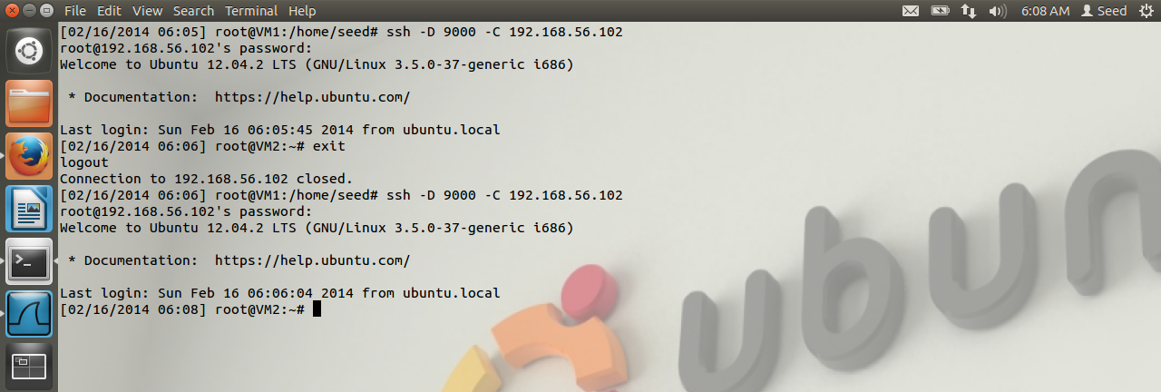

After establishing the SSH tunnel VM1 and VM2 again performs 3-way hand shake. Further communication is done through SSH.

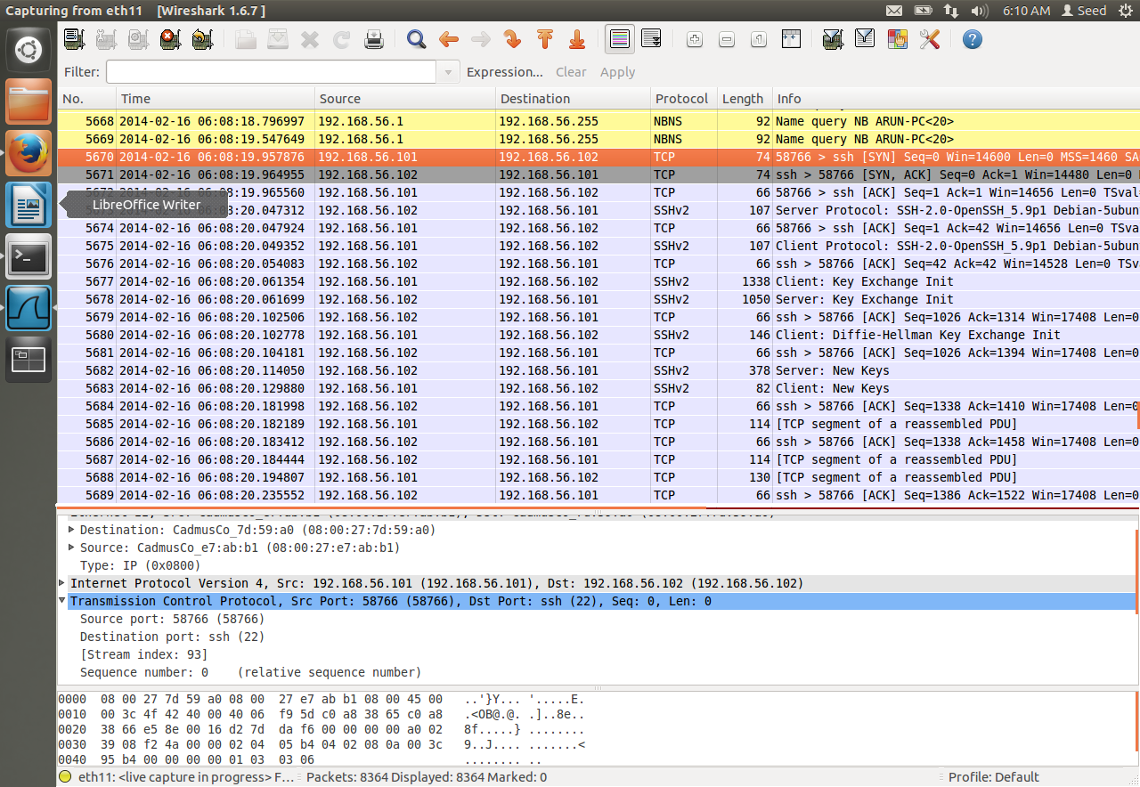

Step 4:

As the packets are sent through SSH they contain only the information about ethernet type, ip information, TCP and SSH and with port number 22. There is no mention of [www.syr.edu’s](http://www.syr.edu's) ip address and port 22 is not blocked so the ufw firewall accepts the packet.

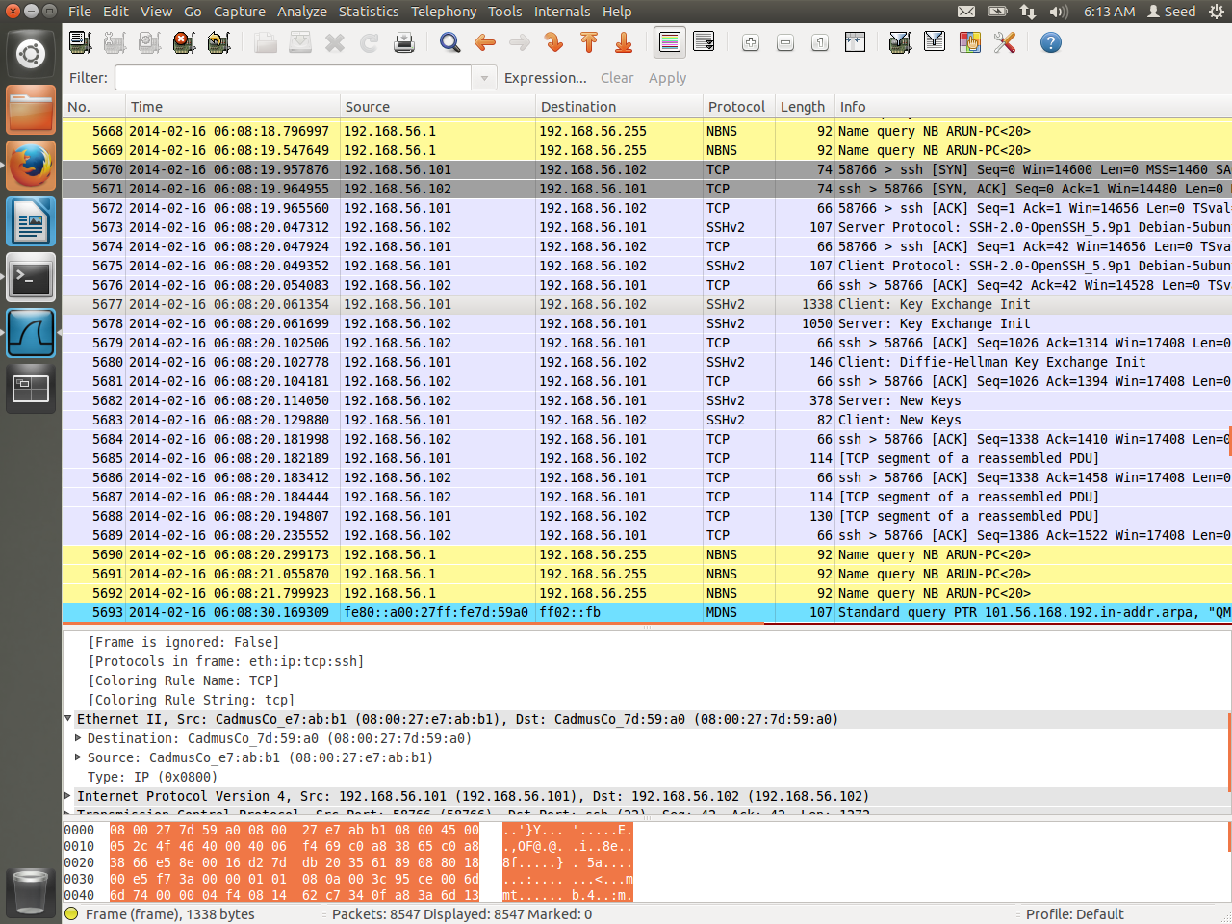

**Question 4:** If ufw blocks the TCP port 22, which is the port used by SSH, can you still set

up an SSH tunnel to evade egress filtering?

Answer:

SSH tunnel can evade egress filtering by changing the port number from 22 to any other number.

This can be done in /etc/ssh/sshd.conf file. Then the the SSH tunnel is restarted with the new port number using “sudo service ssh restart”.

**Task 4: Web Proxy (Application Firewall)**

Firewalls used in the previous tasks can access the transport layer of the packets but do not look inside the data segment. There are also other firewall types which look into the packets in the application layer which contain only the data part. One such firewall is called as squid3.

**Task 4a: setup**

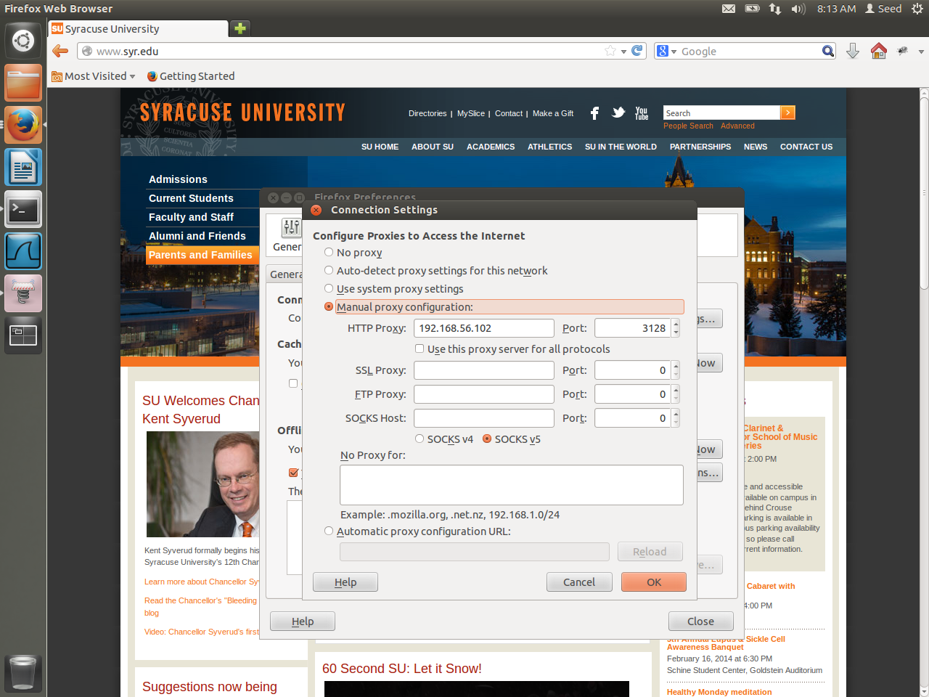

Step :1

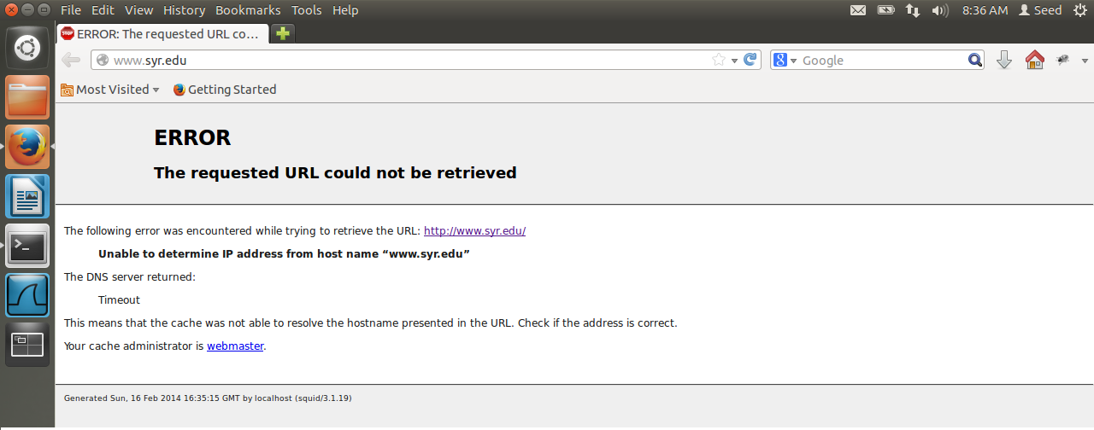

**Observation:**

When VM1 tries to access syr.edu, it is unable to view the webpage. This because when squid3 is enabled in VM2 it denies all access by default.

Step 2:

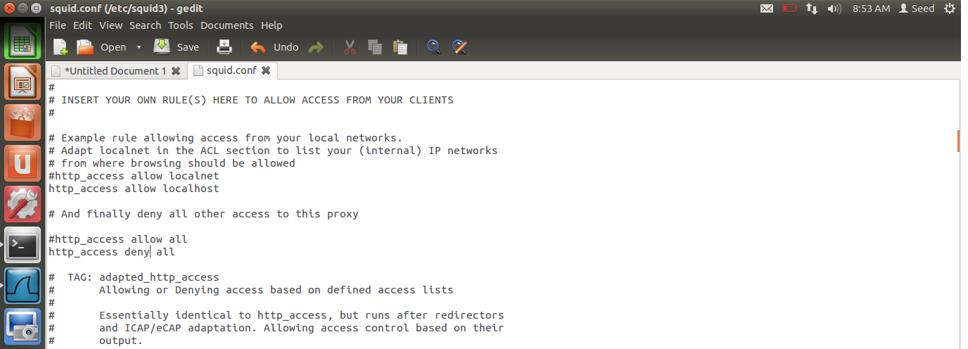

**Observation:**

Inside the /etc/squid.conf file http_access deny all tells that all access to external sites are denied.

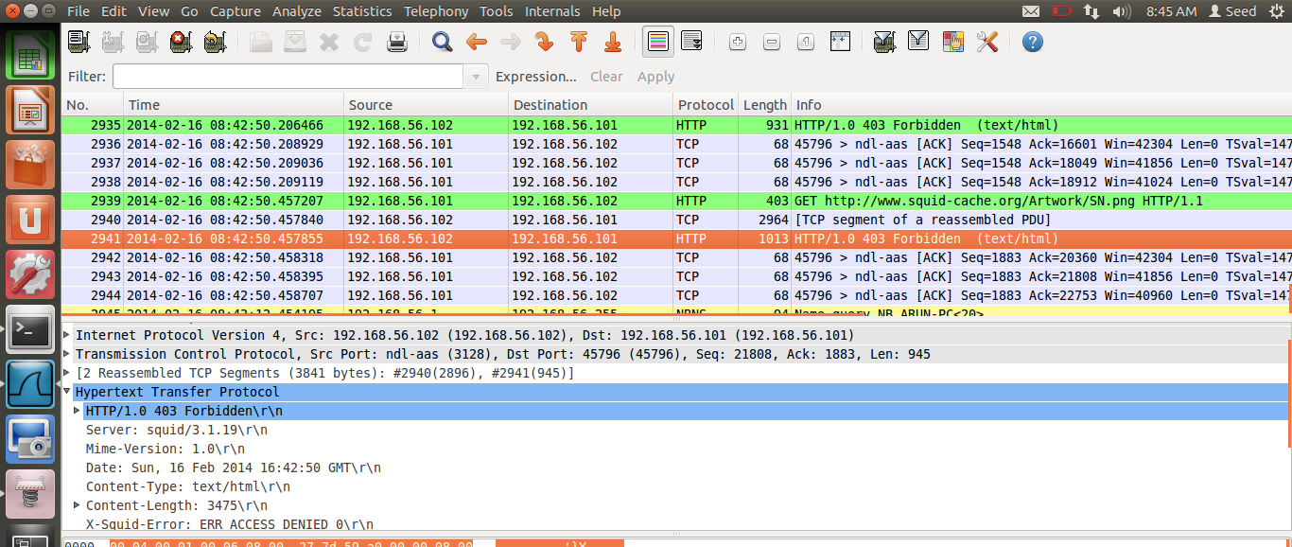

**Observation:**

When VM1 sends the request to access [www.syr.edu](http://www.syr.edu) to VM2, it is denied by VM2 by sending a HTTP packets which tells that site is blocked. (X-Squid-Error: ERR_ACCESS_DENIED)

Step 3:

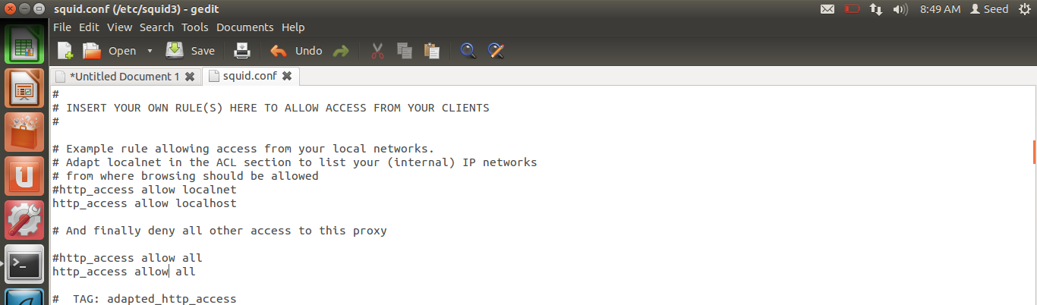

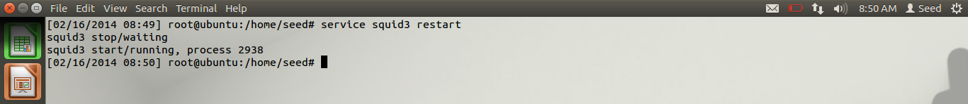

**Observation:**

In the /etc/squid.conf file the line http_access deny all is changed to http_access allow all and the squid service is restarted in VM2. NowVM1 can access any website through squid in VM2.

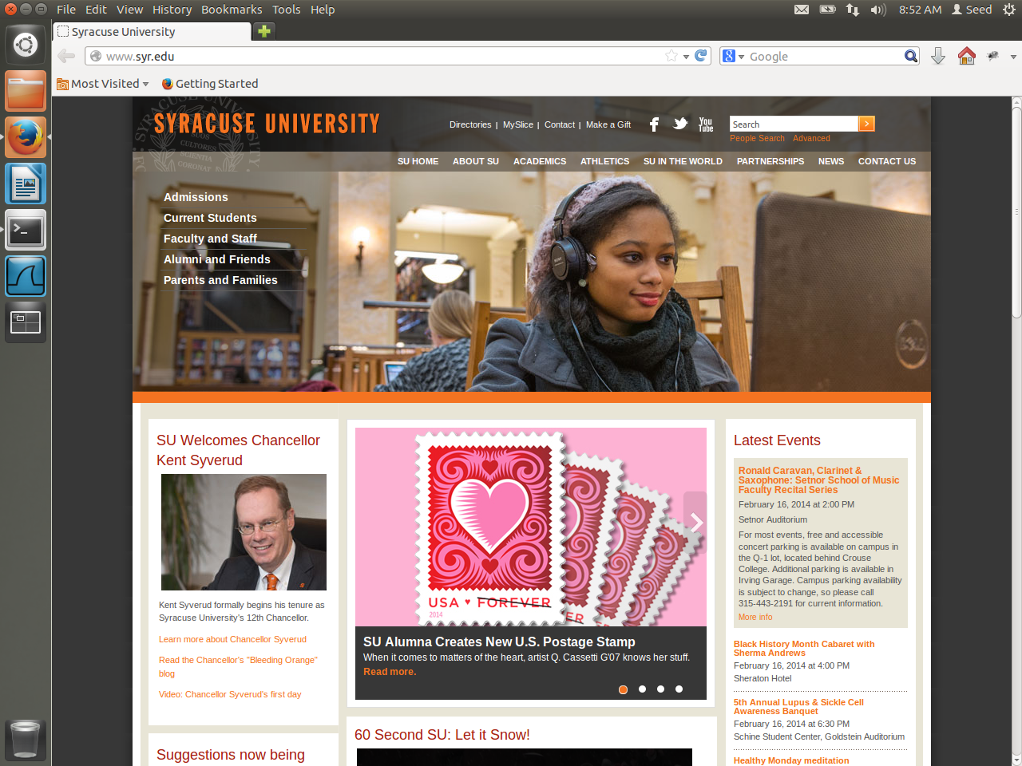

Step 4:

The /etc/squid.conf file in VM2 is changed to allow access only to [www.google.co.in](http://www.google.co.in) and block all other website access.

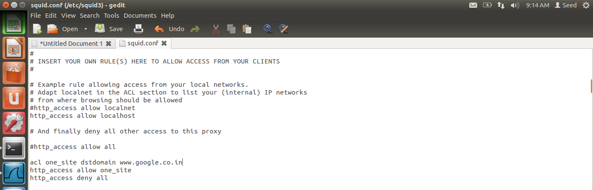

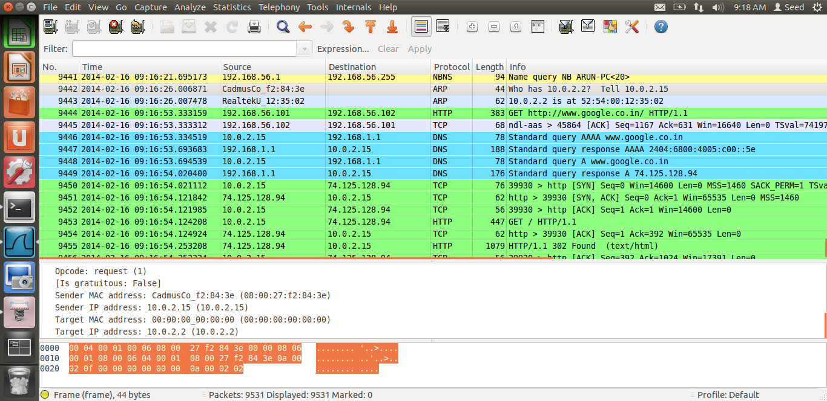

**Observation:**

VM1 can access [www.google.co.in](http://www.google.co.in) from VM2. The packets are forwarded from VM1 to VM2.

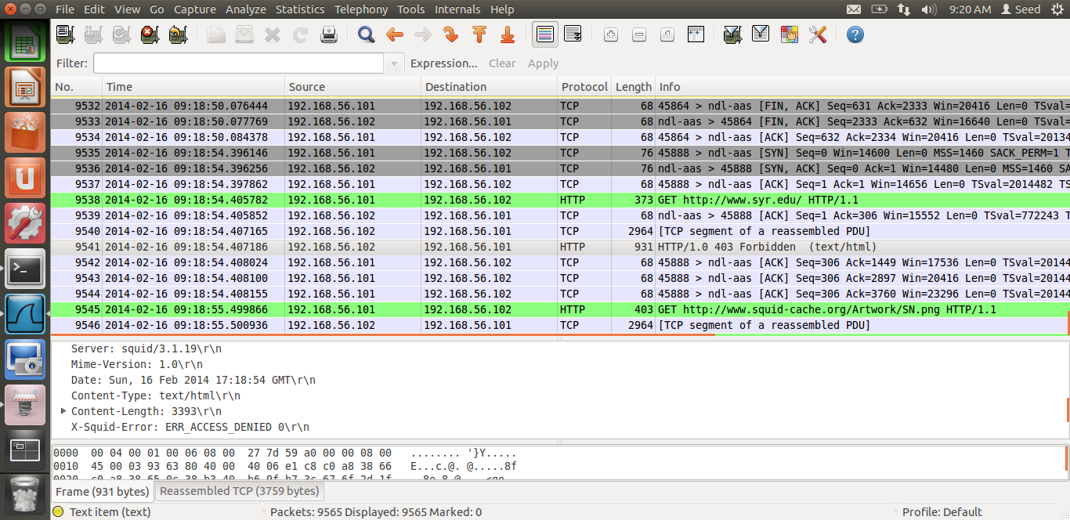

**Observation:**

VM1 cannot access [www.syr.edu](http://www.syr.edu) because squid in VM2 replies with ERR_ACCESS_DENIED message.

**Task 4b: Using Web Proxy to evade Firewall**

VM1 can bypass its firewall policies by changing the HTTP proxy and port number.

Step 1:

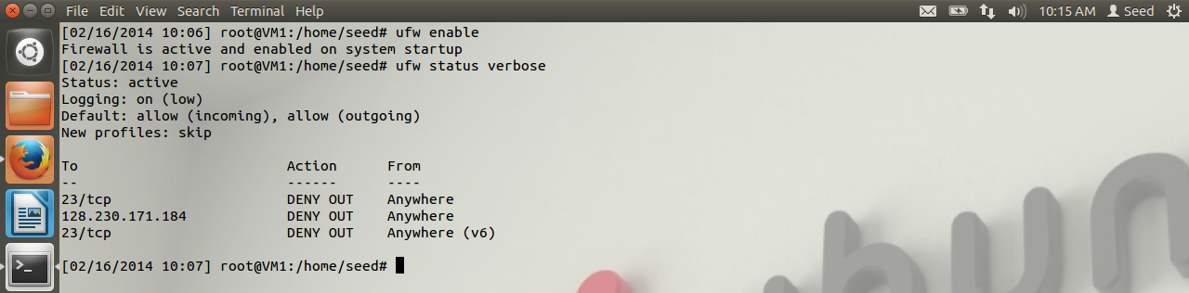

Observation:

The ufw firewall in VM1 blocks access to [www.syr.edu](http://www.syr.edu)

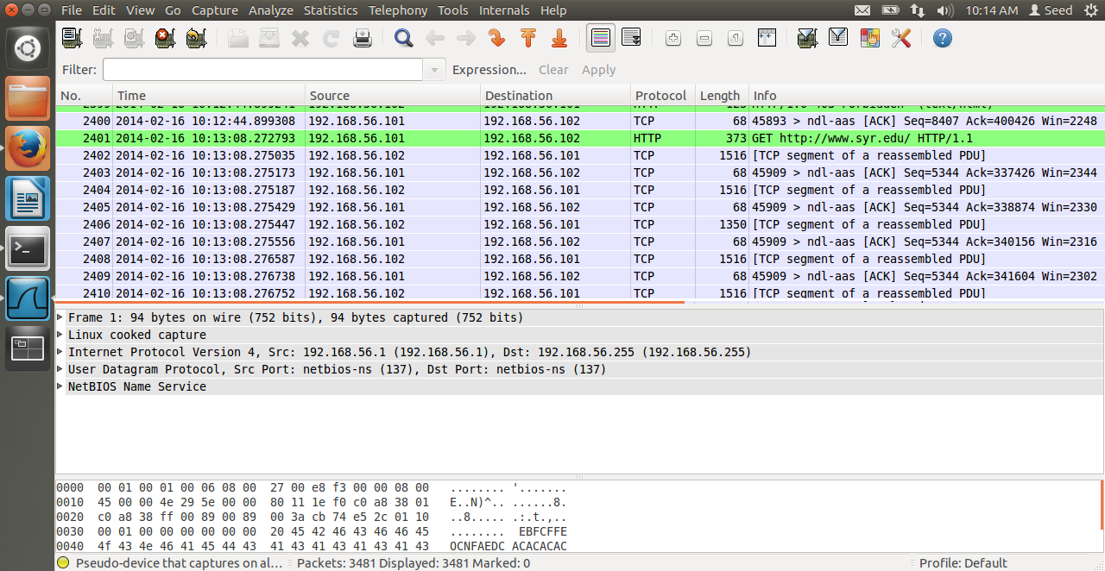

**Observation:**

VM1 sends packets to VM2 requesting each information of syr.edu such as images, links, videos, etc.

**Question 5:**

If ufw blocks the TCP port 3128, can you still use web proxy to evade the firewall?

Answer:

Squid web proxy can listen to multiple ports such as 8000, 8080, 3128, etc. so when a firewall blocks one port the /etc/squid.conf file can be used to access using another port.

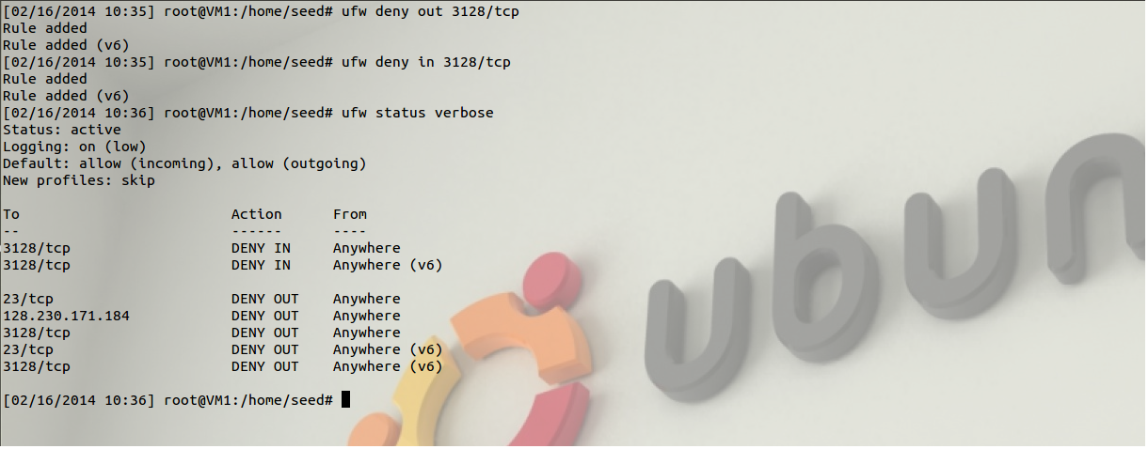

Step 1:

Add the line http_port 8000 in /etc/squid.conf file. Now squid in VM2 listens to both 3128 and 8000.

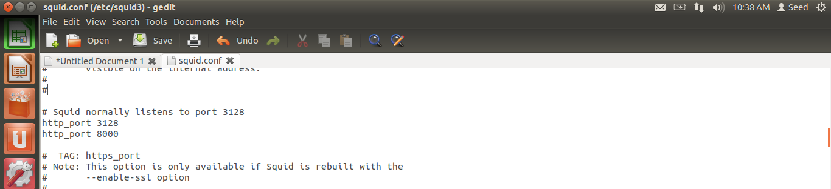

Step 2:

Restart the squid service in VM2 and change the proxy port number to 8000 in VM1.

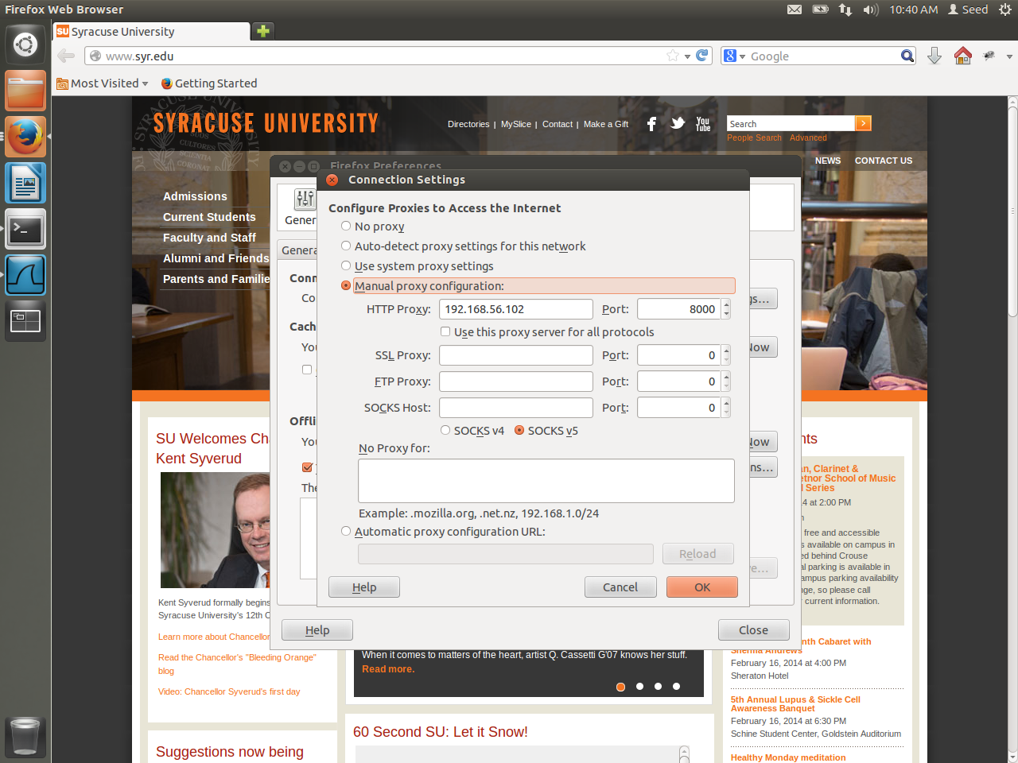

**Task 4c: URL Rewriting/Redirection:**

Squid can also perform url redirection where when a user types in a website he/she is redirected to another site and image.

**Task 4c.1**: Please describe what the above program does (e.g. what URLs got rewritten and what

your observations are).

Answer :

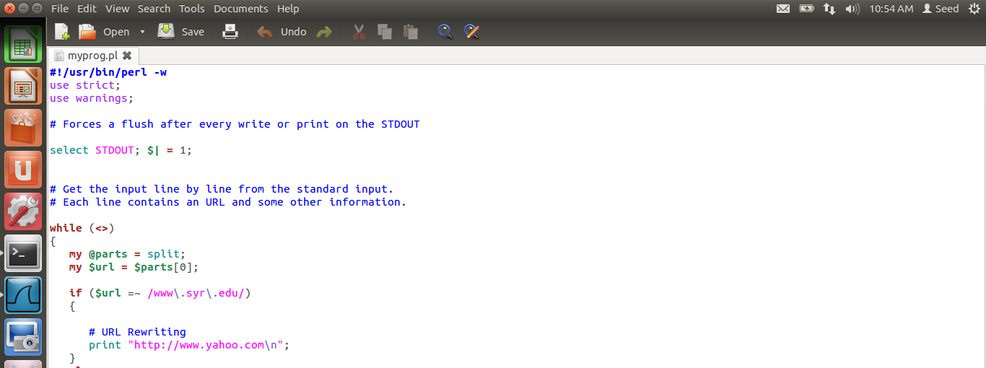

The program myperl.pl is added in /etc/squid3 at

url_rewrite_program /etc/squid3/myprog.pl

when VM tries to access [www.syr.edu](http://www.syr.edu) it re redirected to [www.yahoo.com](http://www.yahoo.com) and when it tries to access any other website there is no redirection.

The program is available in page number 40(myprog.pl)

**Task 4c.2** : Please modify the above program, so it replaces all the Facebook pages with a page that shows a big red stop sign.

Answer:

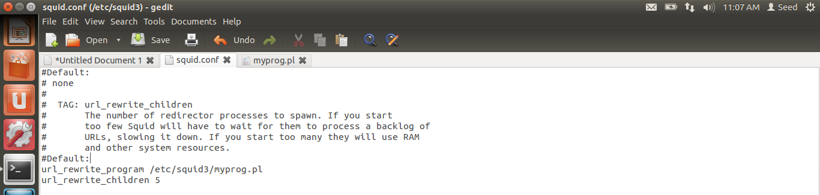

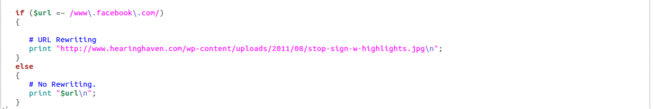

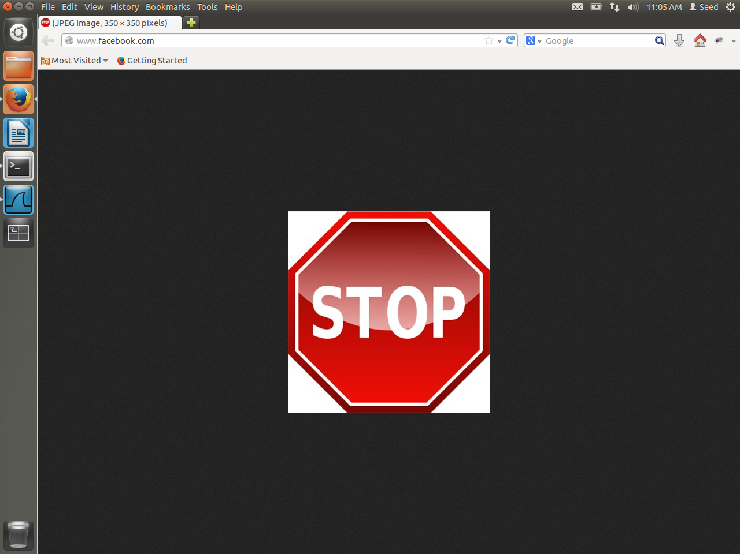

**Observation:**

myprog.pl program is modified so that whenever VM1 tries to access facebook.com it is redirected to a stop sign image. The program is available in page number 40 (page_redirect.pl)

**Task 4c. 3**: Please modify the above program, so it replaces all the images (e.g. .jpg or .gif images)

inside any page with a picture of your choice. When an HTML web page contains images,

the browser will identify those image URLs, and send out an URL request for each image.

You should be able to see the URLs in your URL rewriting program. You just need to

decide whether a URL is trying to fetch an image file of a particular type; if it is, you can

replace the URL with another one (of your choice).

Answer :

Whenever a website is accessed each content in the website such as links, images, videos are requested individually. So myprog.pl can be modified to replace all such request with a single image.

The program is available in page number 41 (image_redirect.pl)

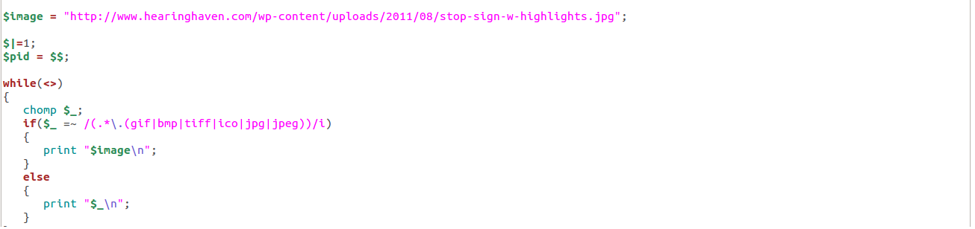

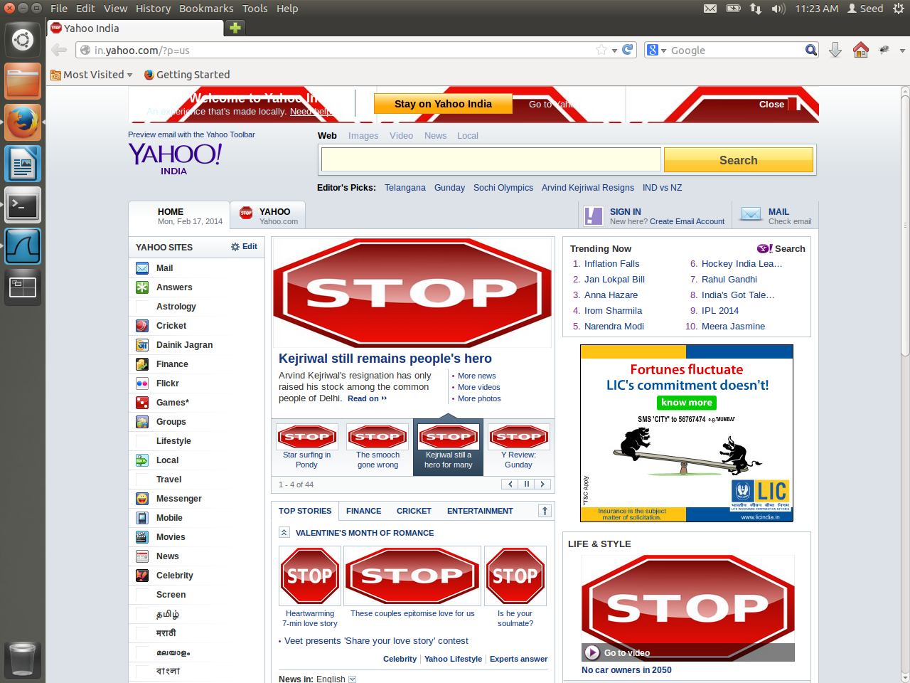

**Observation:**

When VM1 accesses the [www.yahoo.com](http://www.yahoo.com) all images on it are replaced by a stop sign.

**Programs :**

Task 2 : loadable kernel module and netfilter

**LKM_netfilter_rules.c**

#include <linux/kernel.h>

#include <linux/module.h>

#include <linux/netfilter.h>

#include <linux/netfilter_ipv4.h>

#include <linux/skbuff.h>

#include <linux/tcp.h>

#include <linux/icmp.h>

#include <linux/ip.h>

static struct nf_hook_ops nfho_out; //net filter for outgoing packets

static struct nf_hook_ops nfho_in; //net filter for incoming packets

struct sk_buff *sock_buff;

struct iphdr *ip_header; //ip header struct

struct tcphdr *tcp_header; //tcp header struct

struct icmphdr *icmp_header; //icmp header struct

unsigned int src_port, dst_port;

unsigned int hook_func_in(unsigned int hooknum, struct sk_buff *skb, const struct net_device *in, const struct net_device *out, int (*okfn)(struct sk_buff *))

{

sock_buff = skb;

ip_header = (struct iphdr *)skb_network_header(sock_buff); //grab network header using accessor

if(!sock_buff)

{

return NF_ACCEPT;

}

printk(KERN_INFO "\n incoming packet...\n");

//all packets from 192.168.56.103

if(((ip_header->saddr & 0xff000000) >> 24) == 103)

{

printk(KERN_INFO "\n dropping all packets coming ");

printk(KERN_INFO "from :...%d.%d.%d.%d \n",

ip_header->saddr & 0x000000ff,

(ip_header->saddr & 0x0000ff00) >> 8,

(ip_header->saddr & 0x00ff0000) >> 16,

(ip_header->saddr & 0xff000000) >> 24);

return NF_DROP;

}

//end of all packets from 192.168.56.103

//tcp packets

if(ip_header->protocol == 6)

{

tcp_header = (struct tcphdr *)((__u32 *)ip_header + ip_header->ihl); //grab transport header

src_port = (unsigned int) ntohs(tcp_header->source);

dst_port = (unsigned int) ntohs(tcp_header->dest);

//telnet incoming

if(dst_port == 23)

{

printk(KERN_INFO "got tcp telnet packet coming\n");

printk(KERN_INFO "from :...%d.%d.%d.%d \n",

ip_header->saddr & 0x000000ff,

(ip_header->saddr & 0x0000ff00) >> 8,

(ip_header->saddr & 0x00ff0000) >> 16,

(ip_header->saddr & 0xff000000) >> 24);

printk(KERN_INFO "To :...%d.%d.%d.%d \n",

ip_header->daddr & 0x000000ff,

(ip_header->daddr & 0x0000ff00) >> 8,

(ip_header->daddr & 0x00ff0000) >> 16,

(ip_header->daddr & 0xff000000) >> 24);

printk(KERN_INFO "source port no...%d\n destinatio port no...%d\n", src_port, dst_port);

printk(KERN_INFO "dropping tcp telnet request packet\n");

return NF_DROP;

}

//end of telnet incoming

}

//end of tcp packet

//icmp packets

if (ip_header->protocol == 1)

{

icmp_header = (struct icmphdr *)((__u32 *)ip_header + ip_header->ihl); //grab transport header

//incoming ping to 192.168.56.101(local)

if(icmp_header->type == 8 && icmp_header->code == 0 && ((ip_header->saddr & 0xff000000) >> 24) == 102)

{

printk(KERN_INFO "got ping request packet coming \n");

printk(KERN_INFO "from :...%d.%d.%d.%d \n",

ip_header->saddr & 0x000000ff,

(ip_header->saddr & 0x0000ff00) >> 8,

(ip_header->saddr & 0x00ff0000) >> 16,

(ip_header->saddr & 0xff000000) >> 24);

printk(KERN_INFO "To :...%d.%d.%d.%d \n",

ip_header->daddr & 0x000000ff,

(ip_header->daddr & 0x0000ff00) >> 8,

(ip_header->daddr & 0x00ff0000) >> 16,

(ip_header->daddr & 0xff000000) >> 24);

printk(KERN_INFO "dropping ping request packet\n");

return NF_DROP;

}

//end of incoming ping to 192.168.56.101(local)

}

//end of icmp packet

return NF_ACCEPT;

}

//end of for incoming packets

//for outgoing packets

unsigned int hook_func_out(unsigned int hooknum, struct sk_buff *skb, const struct net_device *in, const struct net_device *out, int (*okfn)(struct sk_buff *))

{

sock_buff = skb;

ip_header = (struct iphdr *)skb_network_header(sock_buff); //grab network header using accessor

if(!sock_buff)

{

return NF_ACCEPT;

}

printk(KERN_INFO "\n outgoing packet...\n");

// facebook

if((ip_header->daddr & 0x000000ff) == 31 && ((ip_header->daddr & 0x0000ff00) >> 8) == 13 && (((ip_header->daddr & 0x00ff0000) >> 16) == 64 || ((ip_header->daddr & 0x00ff0000) >> 16) == 86) && ((ip_header->daddr & 0xff000000) >> 24) == 65)

{

printk(KERN_INFO "\n requesting facebook page ");

printk(KERN_INFO "from :...%d.%d.%d.%d \n",

ip_header->saddr & 0x000000ff,

(ip_header->saddr & 0x0000ff00) >> 8,

(ip_header->saddr & 0x00ff0000) >> 16,

(ip_header->saddr & 0xff000000) >> 24);

printk(KERN_INFO "To :...%d.%d.%d.%d \n",

ip_header->daddr & 0x000000ff,

(ip_header->daddr & 0x0000ff00) >> 8,

(ip_header->daddr & 0x00ff0000) >> 16,

(ip_header->daddr & 0xff000000) >> 24);

printk(KERN_INFO " dropping packet\n");

return NF_DROP;

}

//end of facebook

// syr.edu

if((ip_header->daddr & 0x000000ff) == 128 && ((ip_header->daddr & 0x0000ff00) >> 8) == 230 && ((ip_header->daddr & 0x00ff0000) >> 16) == 171 && ((ip_header->daddr & 0xff000000) >> 24) == 184)

{

printk(KERN_INFO "\n requesting syr.edu page ");

printk(KERN_INFO "from :...%d.%d.%d.%d \n",

ip_header->saddr & 0x000000ff,

(ip_header->saddr & 0x0000ff00) >> 8,

(ip_header->saddr & 0x00ff0000) >> 16,

(ip_header->saddr & 0xff000000) >> 24);

printk(KERN_INFO "dropping packet\n");

return NF_DROP;

}

//end of syr.edu

//tcp packets

if(ip_header->protocol == 6)

{

tcp_header = (struct tcphdr *)((__u32 *)ip_header + ip_header->ihl); //grab transport header

src_port = (unsigned int) ntohs(tcp_header->source);

dst_port = (unsigned int) ntohs(tcp_header->dest);

//telnet request

if(dst_port == 23)

{

printk(KERN_INFO "got tcp telnet packet going\n");

printk(KERN_INFO "from :...%d.%d.%d.%d \n",

ip_header->saddr & 0x000000ff,

(ip_header->saddr & 0x0000ff00) >> 8,

(ip_header->saddr & 0x00ff0000) >> 16,

(ip_header->saddr & 0xff000000) >> 24);

printk(KERN_INFO "To :...%d.%d.%d.%d \n",

ip_header->daddr & 0x000000ff,

(ip_header->daddr & 0x0000ff00) >> 8,

(ip_header->daddr & 0x00ff0000) >> 16,

(ip_header->daddr & 0xff000000) >> 24);

printk(KERN_INFO "source port no...%d\n destinatio port no...%d\n", src_port, dst_port);

printk(KERN_INFO "dropping tcp telnet request packet\n");

return NF_DROP;

}

//end of telnet request

//ftp response

if(dst_port == 21)

{

printk(KERN_INFO "got tcp ftp packet coming\n");

printk(KERN_INFO "from :...%d.%d.%d.%d \n",

ip_header->saddr & 0x000000ff,

(ip_header->saddr & 0x0000ff00) >> 8,

(ip_header->saddr & 0x00ff0000) >> 16,

(ip_header->saddr & 0xff000000) >> 24);

printk(KERN_INFO "To :...%d.%d.%d.%d \n",

ip_header->daddr & 0x000000ff,

(ip_header->daddr & 0x0000ff00) >> 8,

(ip_header->daddr & 0x00ff0000) >> 16,

(ip_header->daddr & 0xff000000) >> 24);

printk(KERN_INFO "source port no...%d\n destinatio port no...%d\n", src_port, dst_port);

printk(KERN_INFO "dropping tcp ftp request packet\n");

return NF_DROP;

}

//end of ftp response

}

//end of tcp packet

return NF_ACCEPT;

}

// end of fore outgoing packets

int init_module(void)

{

printk(KERN_INFO "\nincoming packets");

nfho_in.hook = hook_func_in;

nfho_in.hooknum = NF_INET_PRE_ROUTING;

nfho_in.pf = PF_INET;

nfho_in.priority = NF_IP_PRI_FIRST;

nf_register_hook(&nfho_in);

printk(KERN_INFO "\noutgoing packets");

nfho_out.hook = hook_func_out;

nfho_out.hooknum = NF_INET_POST_ROUTING;

nfho_out.pf = PF_INET;

nfho_out.priority = NF_IP_PRI_FIRST;

nf_register_hook(&nfho_out);

return 0;

}

void cleanup_module(void)

{

printk(KERN_INFO "\nbye");

nf_unregister_hook(&nfho_in);

nf_unregister_hook(&nfho_out);

}

**Task 2: optional**

**LKM_fortune_cookie.c**

#include <linux/kernel.h>

#include <linux/module.h>

#include <linux/netfilter.h>

#include <linux/netfilter_ipv4.h>

#include <linux/skbuff.h>

#include <linux/tcp.h>

#include <linux/ip.h>

#include <linux/proc_fs.h>

#include <linux/string.h>

#include <linux/vmalloc.h>

#include <asm/uaccess.h>

#include <linux/init.h>

#include <linux/syscalls.h>

#include <linux/fcntl.h>

MODULE_LICENSE("GPL");

MODULE_DESCRIPTION("Fortune Cookie Kernel Module");

MODULE_AUTHOR("M. Tim Jones");

#define MAX_COOKIE_LENGTH PAGE_SIZE

static struct proc_dir_entry *proc_entry;

static char *cookie_pot; // Space for fortune strings

static int cookie_index; // Index to write next fortune

static int next_fortune; // Index to read next fortune

char str[50], str1[10];

unsigned int ptype, paccess, proto_type, process, b1, ip[4], i, j,src_port, dst_port,cc, cnt, chk, b, length, ret, dp;

static struct nf_hook_ops nfho_in, nfho_out; //net filter hook option struct

struct sk_buff *sock_buff;

struct iphdr *ip_header; //ip header struct

struct tcphdr *tcp_header; //tcp header struct

struct icmphdr *icmp_header; //icmp header struct

struct udphdr *udp_header; //udp header struct

void packet_info(void)//packet information

{

printk(KERN_INFO "from :...%d.%d.%d.%d \n",

ip_header->saddr & 0x000000ff,

(ip_header->saddr & 0x0000ff00) >> 8,

(ip_header->saddr & 0x00ff0000) >> 16,

(ip_header->saddr & 0xff000000) >> 24);

printk(KERN_INFO "To :...%d.%d.%d.%d \n",

ip_header->daddr & 0x000000ff,

(ip_header->daddr & 0x0000ff00) >> 8,

(ip_header->daddr & 0x00ff0000) >> 16,

(ip_header->daddr & 0xff000000) >> 24);

}

int next_us(int b2)

{

int ck1;

ck1=b2;

while(cookie_pot[ck1] != '_' && cookie_pot[ck1] != '\0')

{ck1++;}

return (ck1-b2);

}

ssize_t fortune_write( struct file *filp, const char __user *buff, unsigned long len, void *data )//write into kernel

{

int space_available = (MAX_COOKIE_LENGTH-cookie_index)+1;

if (len > space_available)

{

printk(KERN_INFO "fortune: cookie pot is full!\n");

return -ENOSPC;

}

if (copy_from_user( &cookie_pot[cookie_index], buff, len ))

{

return -EFAULT;

}

cookie_index += len;

cookie_pot[cookie_index-1] = 0;

chk =0; b=0;

chk = next_us(b);

strncpy(str, &cookie_pot[b],chk);

str[chk] = '\0';

chk = chk+1;

b = chk;

//incoming or outgoing

if(strcmp(str, "in") == 0)

ptype = 1;

else if(strcmp(str, "out") == 0)

ptype = 2;

printk(KERN_INFO "...%s...%d\n",str,ptype);

chk = next_us(b);

strncpy(str, &cookie_pot[b],chk);

str[chk] = '\0';

chk = chk+1;

b = b + chk;

//allow or deny

if(strcmp(str, "allow") == 0)

paccess = 1;

else if(strcmp(str, "deny") == 0)

paccess = 2;

printk(KERN_INFO "...%s...%d\n",str,paccess);

chk = next_us(b);

strncpy(str, &cookie_pot[b],chk);

str[chk] = '\0';

chk = chk+1;

b = b + chk;

//protocol

if(strcmp(str, "tcp") == 0)

proto_type = 6;

else if(strcmp(str, "udp") == 0)

proto_type = 17;

if(strcmp(str, "icmp") == 0)

proto_type = 1;

printk(KERN_INFO "...%s...%d\n",str,proto_type);

chk = next_us(b);

strncpy(str, &cookie_pot[b],chk);

str[chk] = '\0';

chk = chk+1;

b = b + chk;

//function

if(strcmp(str, "port") == 0)

process = 1;

else if(strcmp(str, "address") == 0)

process = 2;

else if(strcmp(str, "all") == 0)

process = 3;

printk(KERN_INFO "...%s...%d\n",str,process);

if(process != 3)

{

chk = next_us(b);

strncpy(str, &cookie_pot[b],chk);

str[chk] = '\0';

chk = chk+1;

b = b + chk;

}

printk(KERN_INFO "...%s...\n",str);

return len;

}

int fortune_read( char *page, char **start, off_t off, int count, int *eof, void *data )

{

int len;

if (off > 0)

{

*eof = 1;

return 0;

}

/* Wrap-around */

if (next_fortune >= cookie_index) next_fortune = 0;

len = sprintf(page, "%s\n", &cookie_pot[next_fortune]);

next_fortune += len;

return len;

}

unsigned int hook_func(unsigned int hooknum, struct sk_buff *skb, const struct net_device *in, const struct net_device *out, int (*okfn)(struct sk_buff *))

{

sock_buff = skb;

ip_header = (struct iphdr *)skb_network_header(sock_buff); //grab network header using accessor

if(!sock_buff)

{

printk(KERN_INFO "error in sock buff\n");

return NF_ACCEPT;

}

cc = 0, cnt = 0, chk = 0;

//for tcp packet

if(proto_type == 6)

{

printk(KERN_INFO "got tcp packet \n");

tcp_header = (struct tcphdr *)((__u32 *)ip_header + ip_header->ihl); //grab transport header

packet_info();

src_port = (unsigned int) ntohs(tcp_header->source);

dst_port = (unsigned int) ntohs(tcp_header->dest);

printk(KERN_INFO "source port no...%d\n destinatio port no...%d\n", src_port, dst_port);

if(process == 1)//port

{

// if(dst_port == atoi(str))

if(kstrtouint(str, 10, &dp) == 0)

{

if(dp == dst_port)

{

if(paccess == 1)//allow

{

printk(KERN_INFO "allowing packet \n");

return NF_ACCEPT;

}

else if(paccess == 2)//deny

{

printk(KERN_INFO "dropping packet \n");

return NF_DROP;

}

}

}

return NF_ACCEPT;

}//end of process 1

else if(process == 2)//ip address

{

for(i = 0; i<4; i++)

ip[i]=0;

j = 0;

for(b1 = 0; ; )

{

while(str[chk] != '.' && str[chk] != '\0')

{chk++;}

strncpy(str1, &str[b1],chk-b1);

str1[chk-b1] = '\0';

// ip[j] = atoi(str1);

kstrtouint(str1, 10, &ip[j]);

j++;

if(str[chk] == '\0')

break;

chk+=1;

b1 = chk;

}

if(ptype == 1)//incoming packets

{

if(ip[0] == (ip_header->saddr & 0x000000ff))

{

cc = 1;

if(ip[1] != 0)

{

if(ip[1] != ((ip_header->saddr & 0x0000ff00) >> 8))

cc = 0;

}

if( cc == 1 && ip[2] != 0)

{

if(ip[2] != ((ip_header->saddr & 0x00ff0000) >> 16))

cc = 0;

}

if( cc == 1 && ip[3] != 0)

{

if(ip[3] != ((ip_header->saddr & 0xff00000) >> 24))

cc = 0;

}

}

}

else if(ptype == 2)//outgoing packets

{

if(ip[0] == (ip_header->daddr & 0x000000ff))

{

cc = 1;

if(ip[1] != 0)

{

if(ip[1] != ((ip_header->daddr & 0x0000ff00) >> 8))

cc = 0;

}

if( cc == 1 && ip[2] != 0)

{

if(ip[2] != ((ip_header->daddr & 0x00ff0000) >> 16))

cc = 0;

}

if( cc == 1 && ip[3] != 0)

{

if(ip[3] != ((ip_header->daddr & 0xff000000) >> 24))

cc = 0;

}

}

}

if(cc == 1)//got a match

{

if(paccess == 1)

{

printk(KERN_INFO "allowing packet \n");

return NF_ACCEPT;

}

else if(paccess == 2)

{

printk(KERN_INFO "dropping packet \n");

return NF_DROP;

}

}

return NF_ACCEPT;

}//end of process 2

else if(process == 3)//all packets

{

if(paccess == 1)

{

printk(KERN_INFO "allowing packet \n");

return NF_ACCEPT;

}

else if(paccess == 2)

{

printk(KERN_INFO "dropping packet \n");

return NF_DROP;

}

return NF_ACCEPT;

}//end of process 3

}//end of proto_type 6

//for udp packet

if(proto_type == 17)

{

printk(KERN_INFO "got udp packet \n");

udp_header = (struct udphdr *)((__u32 *)ip_header + ip_header->ihl); //grab transport header

packet_info();

if(process == 2)//ip address

{

for(i = 0; i<4; i++)

ip[i]=0;

j = 0;

for(b1 = 0; ; )

{

while(str[chk] != '.' && str[chk] != '\0')

{chk++;}

strncpy(str1, &str[b1],chk-b1);

str1[chk-b1] = '\0';

// ip[j] = atoi(str1);

kstrtouint(str1, 10, &ip[j]);

j++;

if(str[chk] == '\0')

break;

chk+=1;

b1 = chk;

}

if(ptype == 1)//incoming packets

{

if(ip[0] == (ip_header->saddr & 0x000000ff))

{

cc = 1;

if(ip[1] != 0)

{

if(ip[1] != ((ip_header->saddr & 0x0000ff00) >> 8))

cc = 0;

}

if( cc == 1 && ip[2] != 0)

{

if(ip[2] != ((ip_header->saddr & 0x00ff0000) >> 16))

cc = 0;

}

if( cc == 1 && ip[3] != 0)

{

if(ip[3] != ((ip_header->saddr & 0xff000000) >> 24))

cc = 0;

}

}

}

else if(ptype == 2)//outgoing packets

{

if(ip[0] == (ip_header->daddr & 0x000000ff))

{

cc = 1;

if(ip[1] != 0)

{

if(ip[1] != ((ip_header->daddr & 0x0000ff00) >> 8))

cc = 0;

}

if( cc == 1 && ip[2] != 0)

{

if(ip[2] != ((ip_header->daddr & 0x00ff0000) >> 16))

cc = 0;

}

if( cc == 1 && ip[3] != 0)

{

if(ip[3] != ((ip_header->daddr & 0xff000000) >> 24))

cc = 0;

}

}

}

if(cc == 1)//got a match

{

if(paccess == 1)//allow

{

printk(KERN_INFO "allowing packet \n");

return NF_ACCEPT;

}

else if(paccess == 2)//deny

{

printk(KERN_INFO "dropping packet \n");

return NF_DROP;

}

}//end of cc

return NF_ACCEPT;

}//end of process 2

else if(process == 3)//all packets

{

if(paccess == 1)

{

printk(KERN_INFO "allowing packet \n");

return NF_ACCEPT;

}

else if(paccess == 2)

{

printk(KERN_INFO "dropping packet \n");

return NF_DROP;

}

else //no match

return NF_ACCEPT;

}//end of process 3

}//end of proto_type 17

//for icmp packets

if(proto_type == 1)

{

printk(KERN_INFO "got icmp packet \n");

icmp_header = (struct icmphdr *)((__u32 *)ip_header + ip_header->ihl); //grab transport header

packet_info();

if(process == 2)//ip address

{

for(i = 0; i<4; i++)

ip[i]=0;

j = 0;

for(b1 = 0; ; )

{

while(str[chk] != '.' && str[chk] != '\0')

{chk++;}

strncpy(str1, &str[b1],chk-b1);

str1[chk-b1] = '\0';

// ip[j] = atoi(str1);

kstrtouint(str1, 10, &ip[j]);

j++;

if(str[chk] == '\0')

break;

chk+=1;

b1 = chk;

}

for(b1 = 0; b1 <4; b1++)

printk(KERN_INFO "...%d...\n",ip[b1]);

if(ptype == 1)//incoming packets

{

if(ip[0] == (ip_header->saddr & 0x000000ff))

{

cc = 1;

if(ip[1] != 0)

{

if(ip[1] != ((ip_header->saddr & 0x0000ff00) >> 8))

cc = 0;

}

if( cc == 1 && ip[2] != 0)

{

if(ip[2] != ((ip_header->saddr & 0x00ff0000) >> 16))

cc = 0;

}

if( cc == 1 && ip[3] != 0)

{

if(ip[3] != ((ip_header->saddr & 0xff000000) >> 24))

cc = 0;

}

}

}

else if(ptype == 2)//outgoing packets

{

if(ip[0] == (ip_header->daddr & 0x000000ff))

{

cc = 1;

if(ip[1] != 0)

{

if(ip[1] != ((ip_header->daddr & 0x0000ff00) >> 8))

cc = 0;

}

if( cc == 1 && ip[2] != 0)

{

if(ip[2] != ((ip_header->daddr & 0x00ff0000) >> 16))

cc = 0;

}

if( cc == 1 && ip[3] != 0)

{

if(ip[3] != ((ip_header->daddr & 0xff000000) >> 24))

cc = 0;

}

}

}

if(cc == 1)//got a match

{

if(paccess == 1)//allow

{

printk(KERN_INFO "allowing packet \n");

return NF_ACCEPT;

}

else if(paccess == 2)//deny

{

printk(KERN_INFO "dropping packet \n");

return NF_DROP;

}

}//end of cc

else// no match

return NF_ACCEPT;

}//end of process 2

else if(process == 3)//all packets

{

if(paccess == 1)

{

printk(KERN_INFO "allowing packet \n");

return NF_ACCEPT;

}

else if(paccess == 2)

{

printk(KERN_INFO "dropping packet \n");

return NF_DROP;

}

else //no match

return NF_ACCEPT;

}//end of process 3

printk(KERN_INFO "\ncome here\n");

}//end of proto_type 1

return NF_ACCEPT;

}//end of hook func

int init_module(void)

{

int ret = 0;

cookie_pot = (char *)vmalloc( MAX_COOKIE_LENGTH );

if (!cookie_pot)

{

ret = -ENOMEM;

}

else

{

memset( cookie_pot, 0, MAX_COOKIE_LENGTH );

proc_entry = create_proc_entry( "fortune", 0644, NULL );

if (proc_entry == NULL)

{

ret = -ENOMEM;

vfree(cookie_pot);

printk(KERN_INFO "fortune: Couldn't create proc entry\n");

}

else

{

cookie_index = 0;

next_fortune = 0;

proc_entry->read_proc = fortune_read;

proc_entry->write_proc = fortune_write;

//proc_entry->owner = THIS_MODULE;

printk(KERN_INFO "fortune: Module loaded.\n");

}//else

}//else

printk(KERN_INFO "\nnetfilter...\n");

//incoming packets

nfho_in.hook = hook_func;

nfho_in.hooknum = NF_INET_PRE_ROUTING;

nfho_in.pf = PF_INET;

nfho_in.priority = NF_IP_PRI_FIRST;

nf_register_hook(&nfho_in);

//outgoing packets

nfho_out.hook = hook_func;

nfho_out.hooknum = NF_INET_POST_ROUTING;

nfho_out.pf = PF_INET;

nfho_out.priority = NF_IP_PRI_FIRST;

nf_register_hook(&nfho_out);

return 0;

}

void cleanup_module(void)

{

printk(KERN_INFO "\nbye");

remove_proc_entry("fortune", NULL);

vfree(cookie_pot);

nf_unregister_hook(&nfho_in);

nf_unregister_hook(&nfho_out);

printk(KERN_INFO "fortune: Module unloaded.\n");

}

**Task 4c 1: myprog.pl**

#!/usr/bin/perl -w

use strict;

use warnings;

# Forces a flush after every write or print on the STDOUT

select STDOUT;

$| = 1;

# Get the input line by line from the standard input.

# Each line contains an URL and some other information.

while (<>)

{

my @parts = split;

my $url = $parts[0];

if ($url =~ /www\.syr\.edu/)

{

# URL Rewriting

print "http://www.yahoo.com \n";

}

else

{

# No Rewriting.

print "$url\n";

}

}

**Task 4c 2: (page_redirect.pl)**

#!/usr/bin/perl -w

use strict;

use warnings;

# Forces a flush after every write or print on the STDOUT

select STDOUT;

$| = 1;

# Get the input line by line from the standard input.

# Each line contains an URL and some other information.

while (<>)

{

my @parts = split;

my $url = $parts[0];

if ($url =~ /www\.facebook\.com/)

{

# URL Rewriting

print "http://www.hearinghaven.com/wp-content/uploads/2011/08/stop-sign-w-highlights.jpg\n";

}

else

{

# No Rewriting.

print "$url\n";

}

}

**Task 4c 3: (image_redirect.pl)**

#!/usr/bin/perl -w

use IO::Handle;

use POSIX strftime;

$image = "http://www.hearinghaven.com/wp-content/uploads/2011/08/stop-sign-w-highlights.jpg";

$|=1;

$pid = $$;

while(<>)

{

chomp $_;

if($_ =~ /(.*\.(gif|bmp|tiff|ico|jpg|jpeg))/i)

{

print "$image\n";

}

else

{

print "$_\n";

}

}